**Team 59 Design Notebook**

Kathryn Atherton

Ryan Hellyer

Natalie Zimmermann

**Table of Contents**

|  |  |
| --- | --- |
| **Topic** | **Page Number** |
| Gantt Chart | 2 |
| Workload Distribution | 3 |
| Morphological Chart | 4 |
| Specification Evaluation | 5-7 |
| Work Breakdown Structure | 8 |
| Metrics of Robot Sub-Components | 9 |
| Presentation of Competencies Specifications | 10-16 |
| House of Quality | 17 |
| Functional Block Diagram | 18 |
| Flow Charts | 19-20 |
| Evidence of Research/Ideas | 21-23 |
| Validations | 24-29 |
| Simulations | 30-32 |
| Part Sketches | 33 |
| Meeting Minutes | 34-44 |

**Gantt Chart**--Updated December 6, 2015

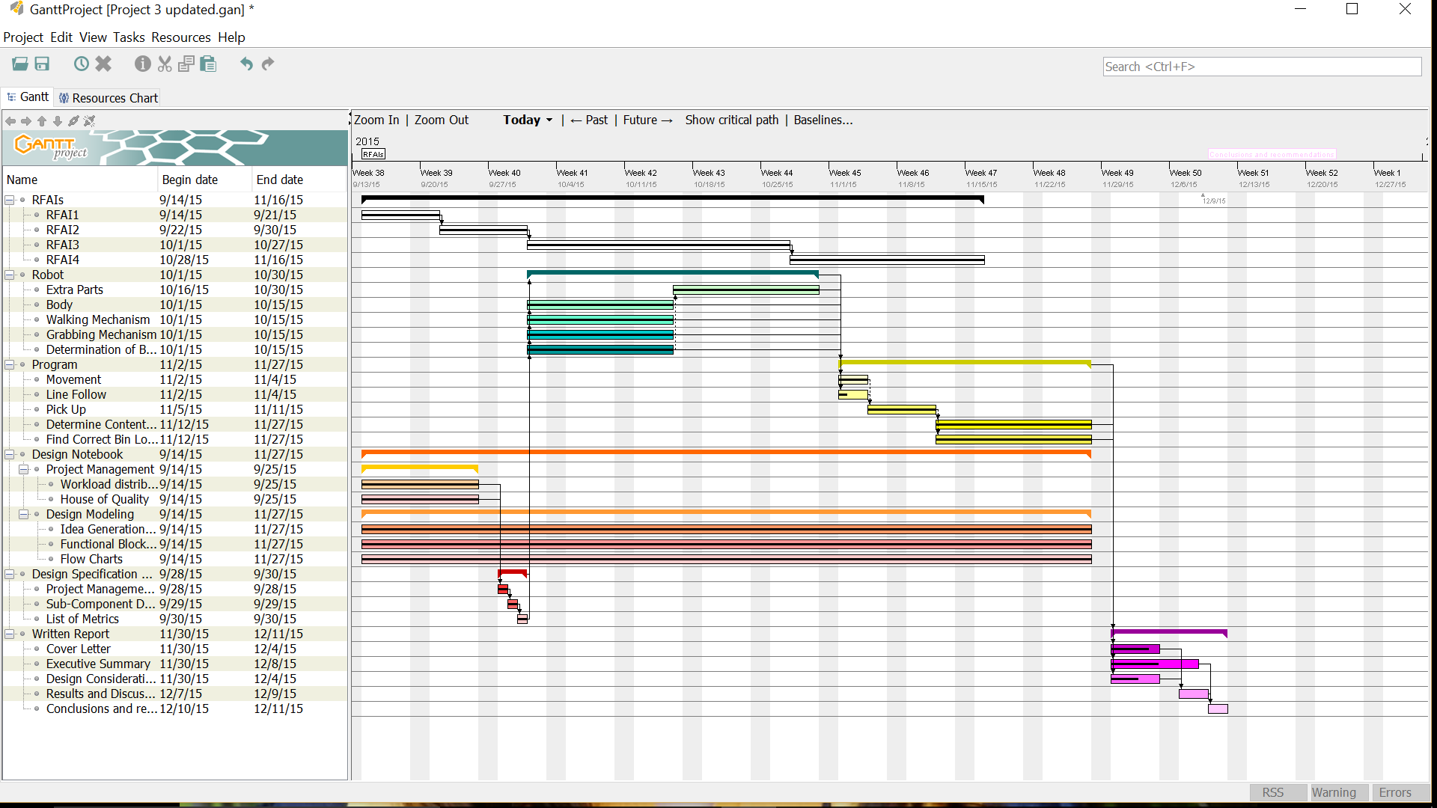

**Workload Distribution**--Updated December 6, 2015



**Morphological Chart** -- Updated December 6, 2015

|  |  |  |  |  |
| --- | --- | --- | --- | --- |
| Function | Mean | | | |
| Walking | 2 bars as feet  “elephant” | 3 or 4 legs on each side “spider” | Combination 2 bars on each side with 4 legs |  |
| Pick-Up | Hook | Forklift |  |  |
| Bin Identification | Displacement of hook “Hooke’s Law”  Ultrasonic Sensor | Power needed to lift weight  Touch Sensor |  |  |
| Drop-Off Location | Touch sensor  Walk into a drop-off location identifier | Ultrasonic sensor  Stop when object detected at a certain distance |  |  |
| Bin Location | Touch sensor  Walk into bin |  |  |  |

**Specification Evaluation --** Updated December 6, 2015

-- Pick Up

|  |  |  |
| --- | --- | --- |
| Specification / Design | Hook | Forklift |
| Weight able to lift > 125 grams | No | Yes |

-- Drop-Off Location

|  |  |  |
| --- | --- | --- |
| Specification / Design | Touch Sensor | Ultrasonic Sensor |
| Distance between the center of the robot at its stop and the center of the bin drop off circle < 6 inches. | No | Yes |
| The time between the robot’s stop at the drop-off point and first identification beep must be less than 3 seconds. | Yes | Yes |

**--** Bin Identification

|  |  |  |
| --- | --- | --- |
| Specification / Design | Power | Hooke’s Law |
| Robot must be able to identify the bin containing the organic materials, knowing that the bin will have a mass of 55-75 grams. | Yes | No |
| When the robot outputs ‘ceramic materials’, the weight output is between 80 and 110 grams. | Yes | No |
| When the robot outputs ‘metallic materials’, the weight output is between 110 and 140 grams. | Yes | No |

**--** Mobility

|  |  |  |  |
| --- | --- | --- | --- |
| Specification / Design | 2 bars as feet  “elephant” | 3 or 4 legs on each side “spider” | Combination 2 bars on each side with 4 legs |
| Measure the distance the robot moves every 60 seconds. This distance should be at least 18 feet. (Average velocity is > 0.3 feet/second) | No--0.23 feet/sec | No--0.25 feet/sec | No--0.27 feet/sec |
| The deviation of the robot perpendicular to the desired path (distance between the center of the robot and the center of the desired path) should be less than 2.4 inches for every foot the robot travels. | No | No | Yes |
| The robot can overcome obstacles 0.5 inches tall or shorter. | No | No | Yes |
| The measured distance the robot moves after one minute intervals should be at least 30 feet when moving over obstacles. (Average velocity is > 0.5 feet/second) | No | No | Yes |

**Work Breakdown Structure**--Updated November 14, 2015

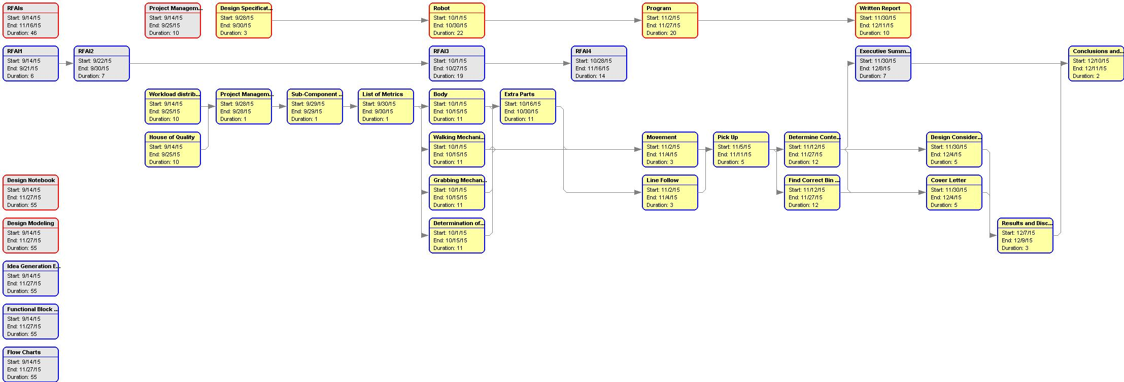

**Metrics of Robot Sub-Components--**Updated November 14, 2015

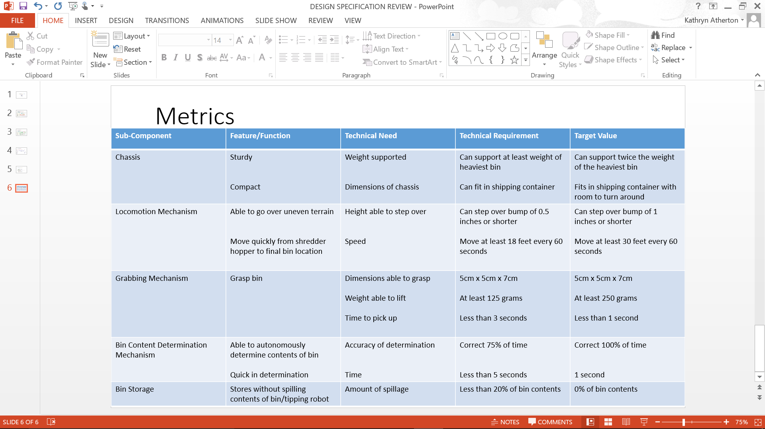

**Presentation of Competencies Specification**--Updated December 6, 2015

|  |  |  |  |  |
| --- | --- | --- | --- | --- |
| **Customer Need** | **Technical Need** | **Technical Requirement** | **Target Value** | **Current Performance** |
| **Mobility Demonstration** | | | | |
| Move fast | The robot’s average velocity is greater than Harris Corporation’s stated minimum velocity. | Measure the distance the robot moves every 60 seconds. This distance should be at least 18 feet. (Average velocity is > 0.3 feet/second) | The measured distance the robot moves after one minute intervals should be at least 36 feet. (Average velocity is > 0.6 feet/second) | Our robot moves 14.6 feet in one minute (an average velocity of 0.243 feet/ second). |
| Move straight | The amount of deviation from the desired path of the robot should be a small distance. | The deviation of the robot perpendicular to the desired path (distance between the center of the robot and the center of the desired path) should be less than 2.4 inches for every foot the robot travels. | The deviation of the robot perpendicular to the desired path (distance between the center of the robot and the center of the desired path) should be less than 1.2 inches for every foot the robot travels. | The deviation of the robot from the center of the path, after moving 1 foot, was 2.2 inches. |
| **Line Follow** | | | | |
| Follow a line | The amount of deviation between the center of the line and the center of the robot should be a small distance. | The deviation of the robot perpendicular to the desired path (distance between the center of the robot and the center of the desired path) should be less than 2.4 inches for every foot the robot travels. | The deviation of the robot perpendicular to the desired path (distance between the center of the robot and the center of the desired path) should be less than 1.2 inches for every foot the robot travels. | The deviation of the robot perpendicular to the desired path is 3.6 inches after the robot travels 1 foot. |
| Follow a curved line | The robot should be able to follow a curve in the line as closely as possible. | The robot should be able to follow a circular path of radius 6 inches with a deviation of less than 1 inch for every cycle around the circle. | The robot should be able to follow a circular path of radius 4 inches with a deviation of less than 1 inch for every cycle around the circle. | The robot follows a circular path with a radius of 4 inches with a cumulative deviation of 12 inches for every cycle around the circle. |
| Find a line | The robot must be able to detect a black solid, dotted, and/or dashed line within a small amount of time. | Time to find line (if robot has deviated or line is broken) < 5 seconds while robot is following the line | Time to find line (if robot has deviated or line is broken) < 5 seconds while robot is following the line | The robot takes 2 seconds for every inch it is from the line to find the line while following it. |
| **Obstacle Traversal** | | | | |
| Overcome obstacles | The robot must be able to overcome small obstacles in its path. | The robot can overcome obstacles 0.5 inches tall or shorter. | The robot can overcome obstacles 1 inch tall or shorter. | The robot can overcome obstacles 1.75 inches tall or shorter. |
| Move quickly over irregular terrain | Robot must move over irregular terrain (squishy, slippery, rough, uphill, downhill, uneven, etc.) without slowing its pace. | Measure the distance the robot moves every 60 seconds. This distance should be at least 18 feet. (Average velocity is > 0.3 feet/second) | The measured distance the robot moves after one minute intervals should be at least 30 feet. (Average velocity is > 0.5 feet/second) | Our robot moves 14.6 feet in one minute (an average velocity of 0.243 feet/ second). |
| **Bin Drop-Off Location** | | | | |
| Locate bin drop-off points | Robot must stop at bin drop-off points. | Distance between the center of the robot at its stop and the center of the bin drop off circle < 6 inches. | Distance between the robot’s grasping mechanism at its stop and the center of the bin drop off circle < 3 inches. | The distance between the back of the robot’s grasping mechanism and the center of the bin drop off circle is 4 inches. |
| Make known that a bin drop-off point has been identified. | The robot must beep three times once the bin drop-off location has been identified. | The time between the robot’s stop at the drop-off point and first identification beep must be less than 3 seconds. | The time between the robot’s stop at the drop-off point and first identification beep must be less than 1 second. | The time between the robot’s stop at the drop-off point and the identification beeps is negligible, or about 0 seconds. |
| **Lift, Transport, and Drop Bin** | | | | |
| Lift a bin | Robot must be able to pick up the bins. | Weight able to lift > 125 grams | Weight able to lift > 250 grams | The Robot can lift 200 grams of mass |
| Transport quickly | Robot must be able to move with weight of bin without slowing pace. | Measure the distance the robot moves every 60 seconds. This distance should be at least 18 feet. (Average velocity is > 0.3 feet/second) | The measured distance the robot moves after one minute intervals should be at least 36 feet. (Average velocity is > 0.6 feet/second) | The robot moves 8 feet every minute while carrying a bin. |
| Transport a bin | Robot must be able to move a minimum distance while carrying bin. | Distance moved with bin > 15 feet (estimated distance to drop off point from the original bin position) | Distance moved with bin > 30 feet (twice the estimated distance to drop off point from the original bin position) | The robot moves about 1 foot with a bin. |
| Prevent dropping of the bin. | Robot must be able to transport the bins without dropping the bins at unwanted locations. | The robot can successfully carry the bins to their respective drop-off points 70% of the time. | The robot can successfully carry the bins to their respective drop-off points 100% of the time. | The robot successfully carries the bins to their respective drop-off points 50% of the time without dropping. |
| Drop a bin. | Robot must be able to accurately set down bins. | Distance between center of bin in its final location and center of bin drop-off circle < 6 inches | Distance between center of bin in its final location and center of bin drop-off circle < 3 inches | The distance between the center of the bin and its final location is 3 inches from the center of the drop-off circle |
| Orient a bin correctly upon drop-off. | Robot must be able to set down bins in the orientation in which they were picked up (with the handle on the top). | The robot places the bin so that the handle is on the top of the bin and the surface area of the base below the forklift slots touching the ground within the drop-off circle is 2500 square millimeters. | The robot places the bin so that the handle is on the top of the bin and the surface area of the base below the forklift slots touching the ground within the drop-off circle is 2500 square millimeters. | The robot places the bin so that the handle is on the top of the bin and the surface area of the base below the forklift slots touching the ground within the drop-off circle is 2500 square millimeters. |
| Disengage from the bin and continue its tasks. | Robot must quickly lose contact with bin once it has been properly placed and continue around the path. | Ten seconds after arriving at the drop-off point the robot should have no point of contact with the bin. The distance between the bottom of the bin and the ground should be 0 inches and the distance between any point on the outside of the bin and the robot should be greater than 0 inches. | Five seconds after arriving at the drop-off point the robot should have no point of contact with the bin. The distance between the bottom of the bin and the ground should be 0 inches and the distance between any point on the outside of the bin and the robot should be greater than 5 inches. | The Robot disengages with the bin after 5.66 seconds |
| **Bin Identification** | | | | |
| Identify the organic materials. | Robot must be able to identify the bin containing the organic materials, knowing that the bin will have a mass of 55-75 grams. | The power required to lift the bin should be less than level 55. | The power required to lift the bin should be less than level 55. | The power required to lift the bin is level 55. |
| Identify the ceramic materials. | Robot must be able to identify the bin containing the ceramic materials, knowing that the bin will have a mass of 85-105 grams. | The power required to lift the bin should be less than level 65, but greater than level 55. | The power required to lift the bin should be less than level 65, but greater than level 55. | The power required to lift the bin is level 65. |
| Identify the metallic materials. | Robot must be able to identify the bin containing the metallic materials, knowing that the bin will have a mass of 115-135 grams. | The power required to lift the bin should be less than level 100, but greater than level 65. | The power required to lift the bin should be less than level 100, but greater than level 65. | The power required to lift the bin is level 75. |
| Identify bins quickly | Robot must be able to determine the contents of the bins in a small amount of time. | Time to determine bin < 5 seconds | Time < 1 second | The robot determines the identity of the bin in 4 seconds. |
| Display the identified material: organic materials | Robot must display that it has identified organic materials on the screen. | When the robot outputs ‘organic materials’, the time to identify the bin is less than 2 seconds. | When the robot outputs ‘organic materials’, the time to identify the bin is less than 2 seconds. | The robot takes 2 seconds after lifting an organic bin to output ‘organic’. |
| Display the identified material: ceramic materials | Robot must display that it has identified ceramic materials on the screen. | When the robot outputs ‘ceramic materials’, the time to identify the bin is less than 4 seconds. | When the robot outputs ‘ceramic materials’, the time to identify the bin is less than 4 seconds. | The robot takes 4 seconds after lifting a ceramic bin to output ‘ceramic’. |
| Display the identified material: metallic materials | Robot must display that it has identified metallic materials on the screen. | When the robot outputs ‘metallic materials’, the time to identify the bin is less than 6 seconds. | When the robot outputs ‘metallic materials’, the time to identify the bin is less than 6 seconds. | The robot takes 6 seconds after lifting a metallic bin to output ‘metallic’. |

**House of Quality**--Updated December 10, 2015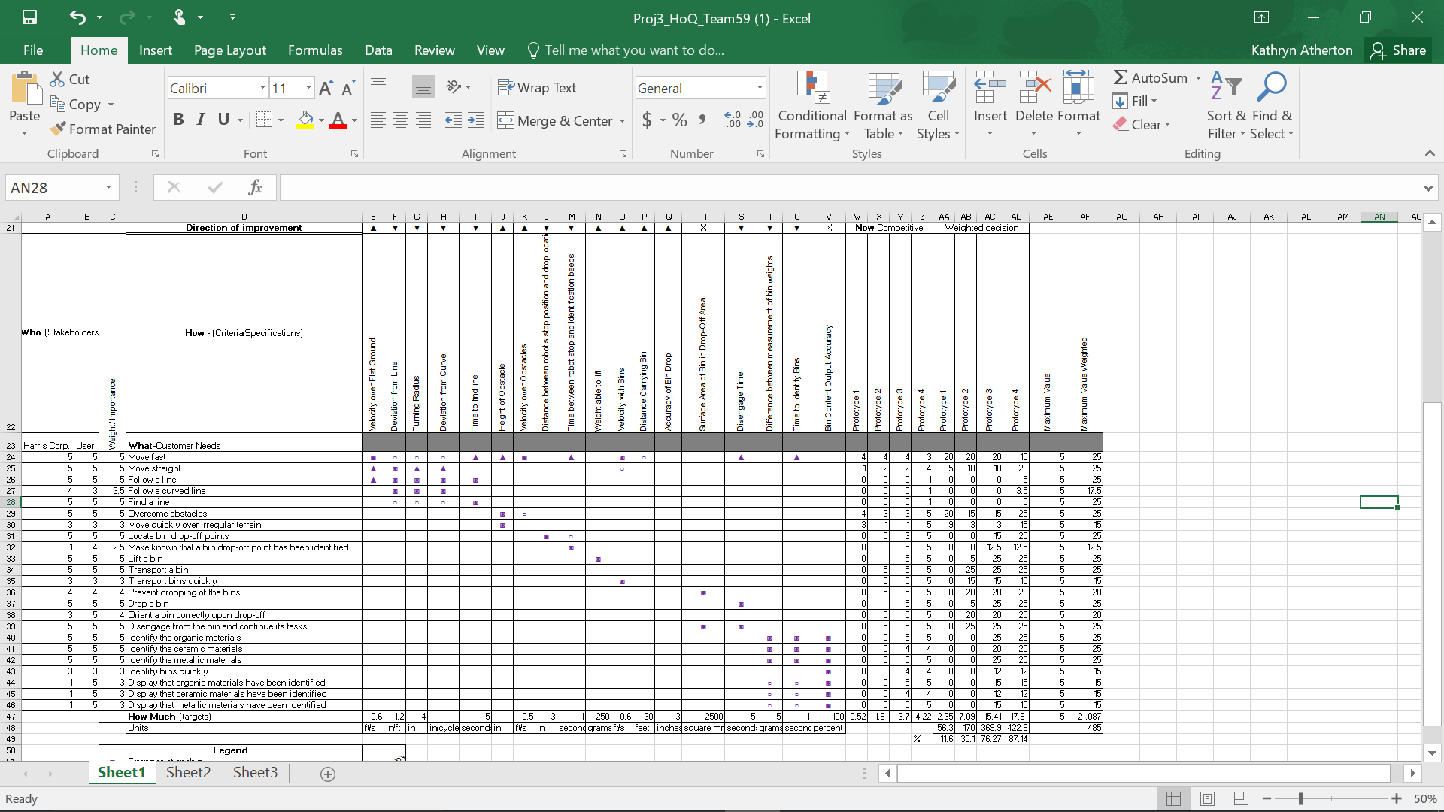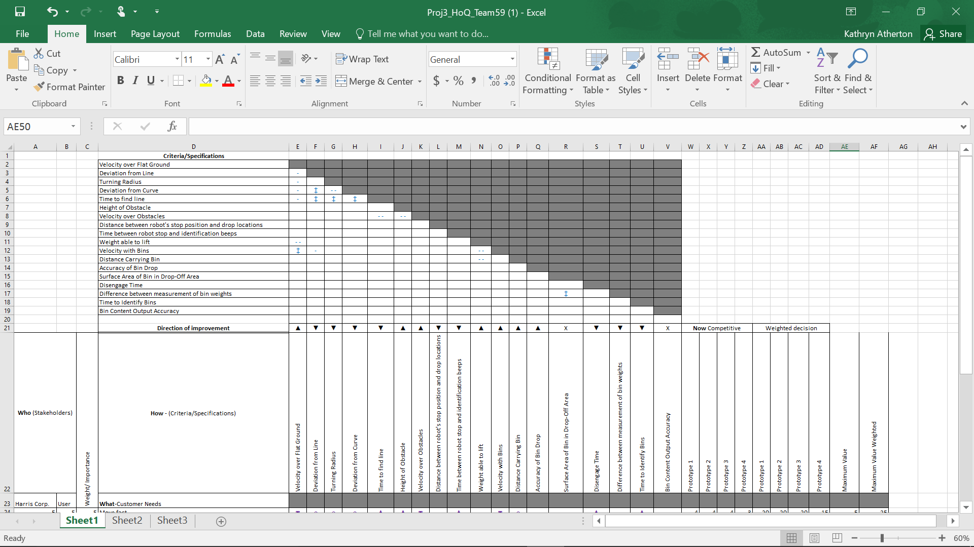

**Functional Block Diagram**--UpdatedNovember 14, 2015

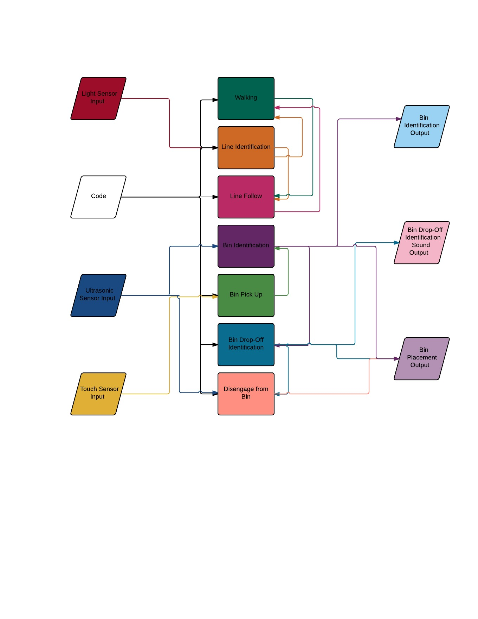

**Flow Charts**--Updated October 23, 2015

Grasping mechanism: 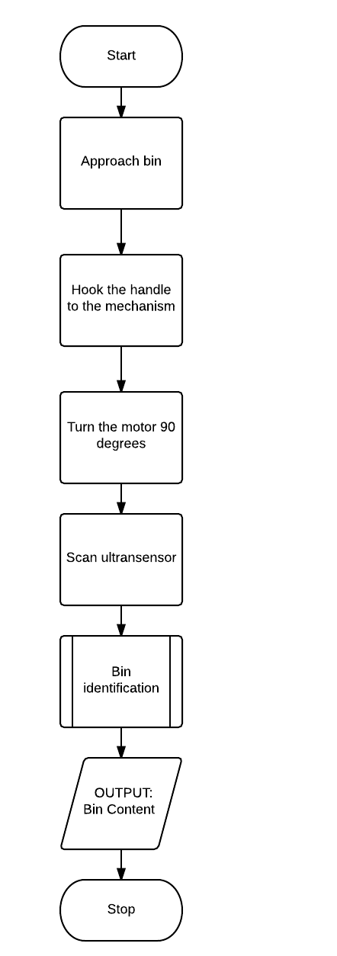

Design/Building process:

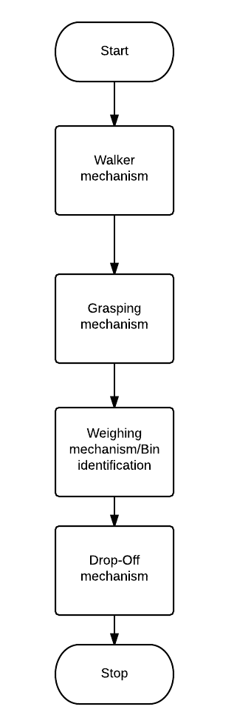

Code:

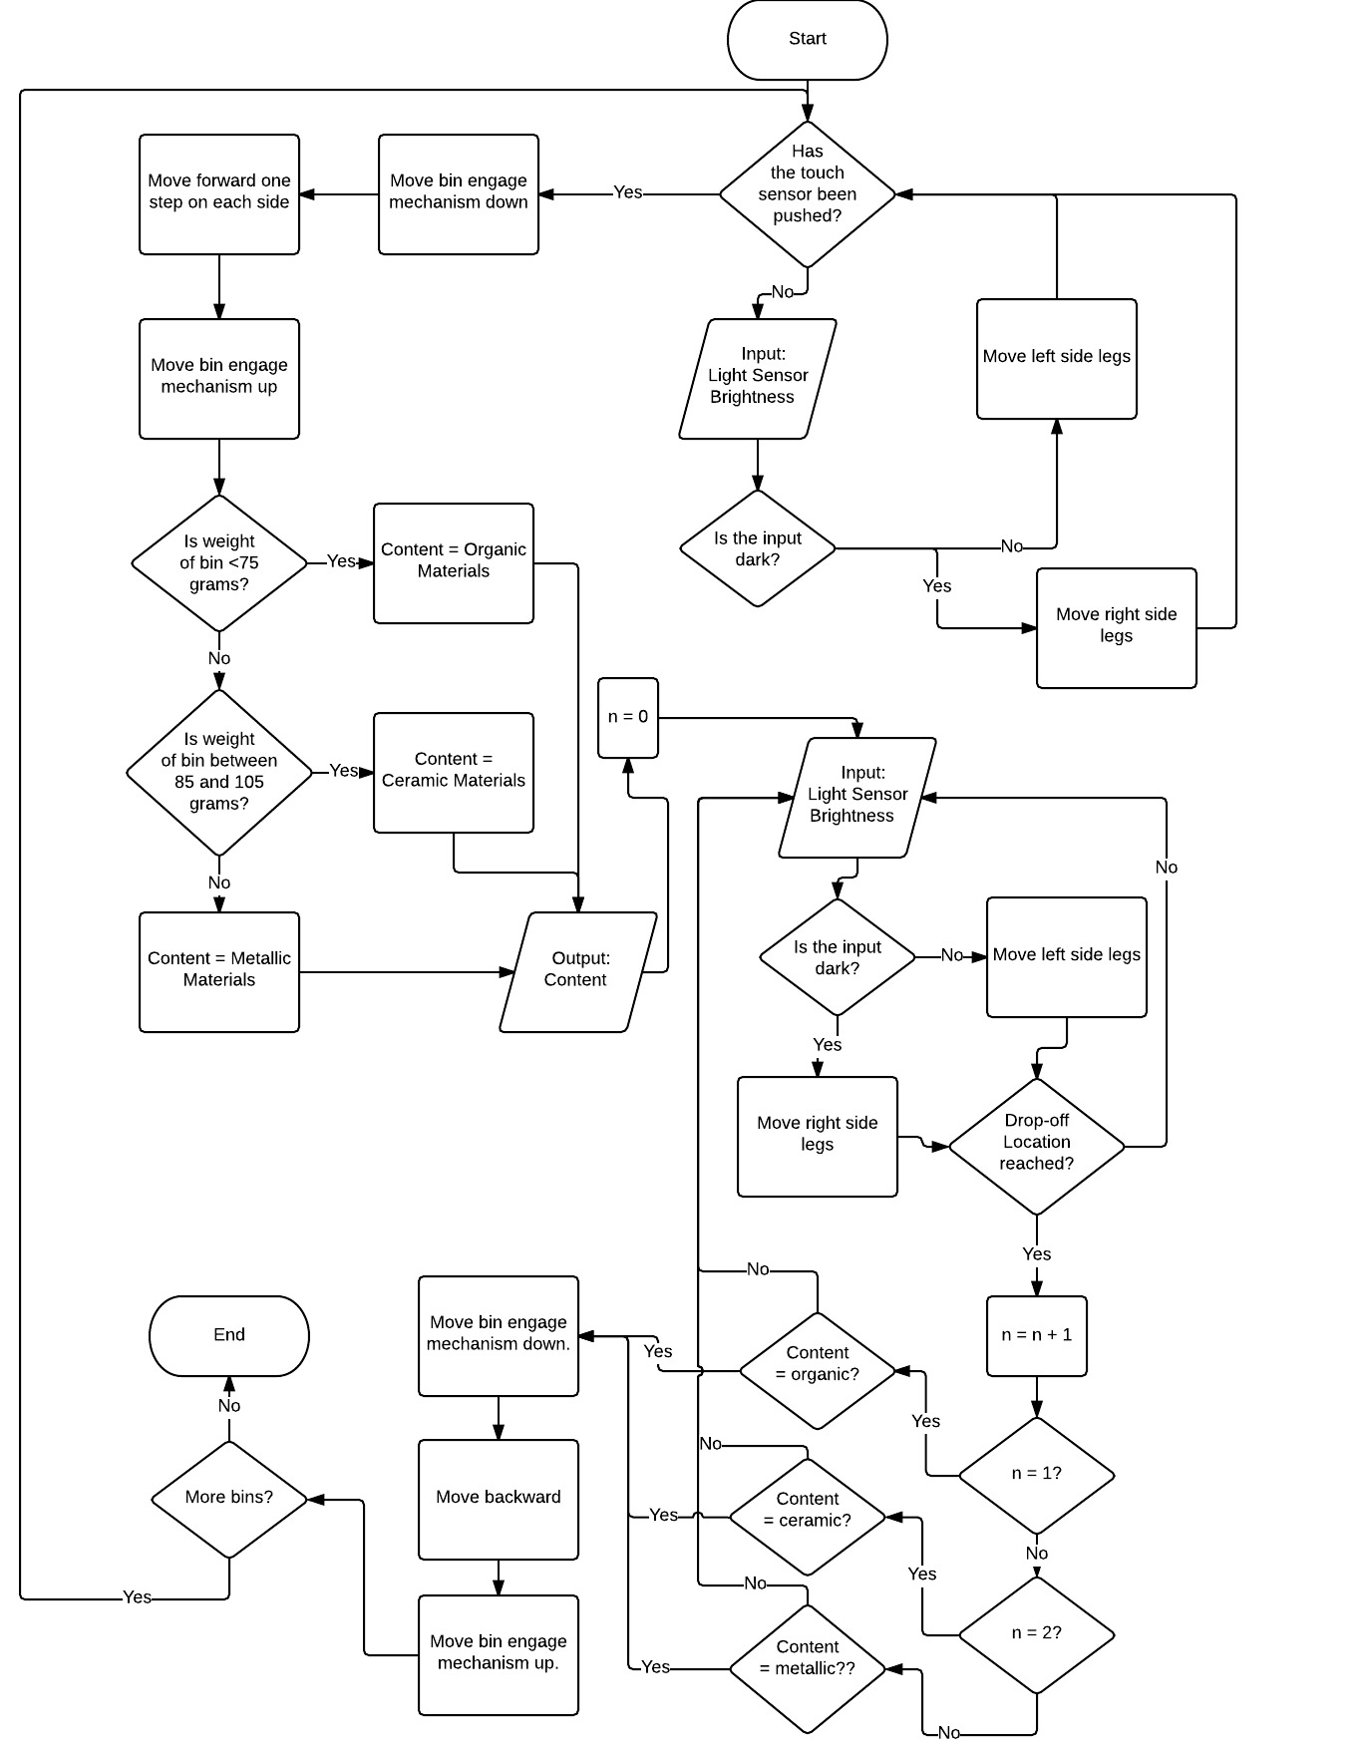

**Evidence of Research/Ideas--** Updated October 2, 2015

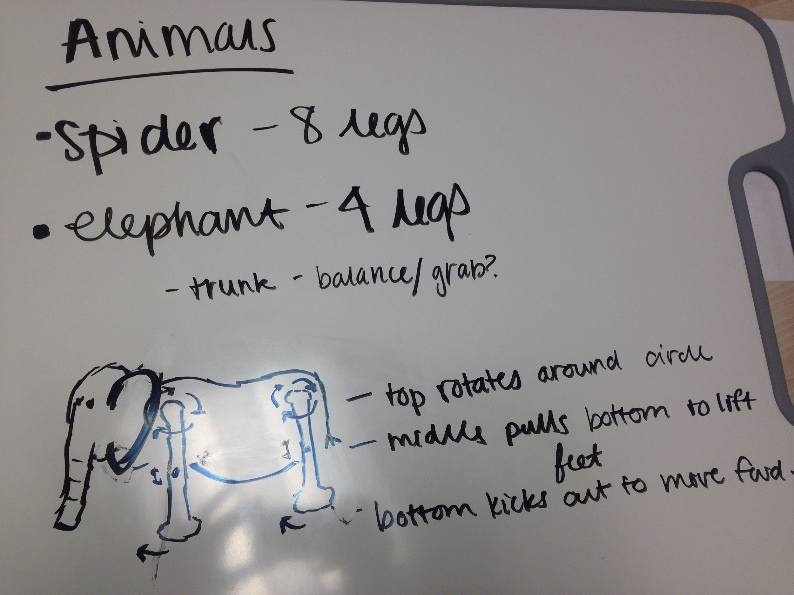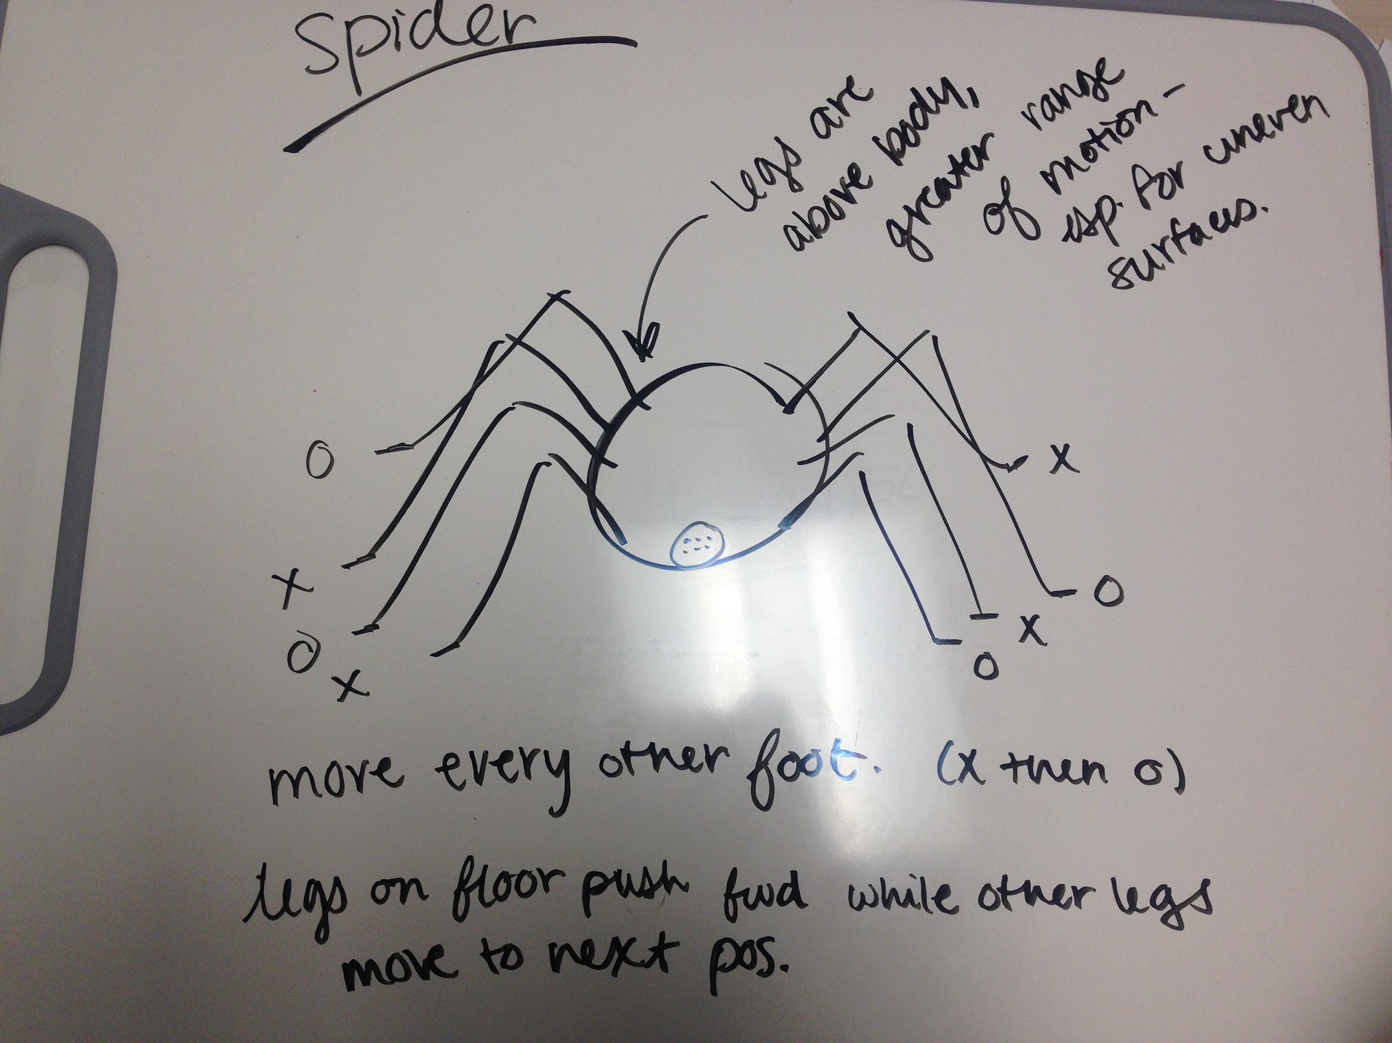

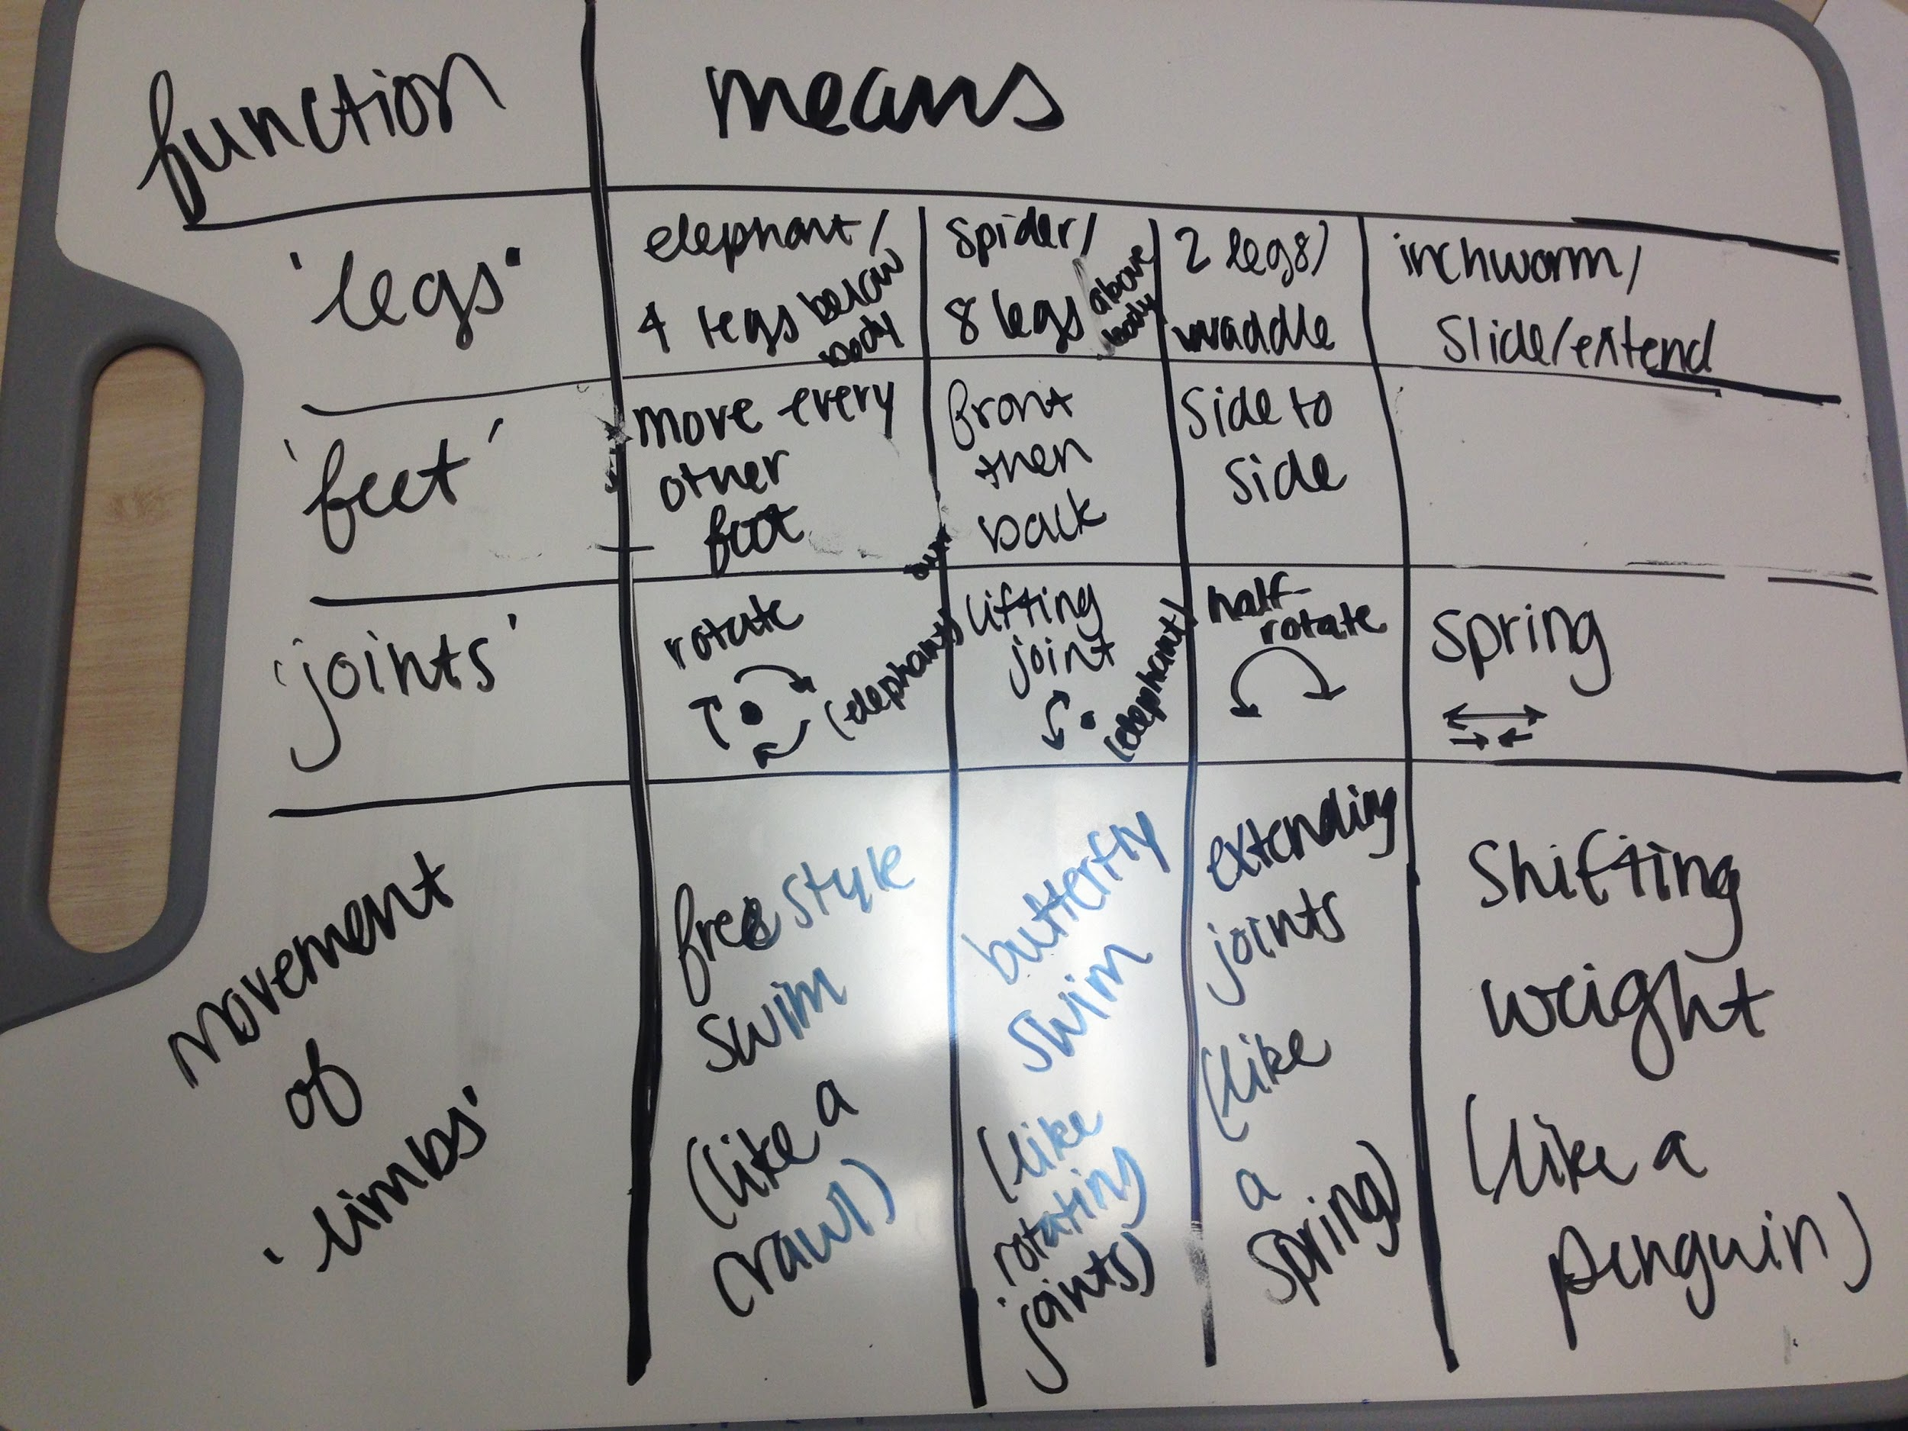

-- Requests for Additional Information

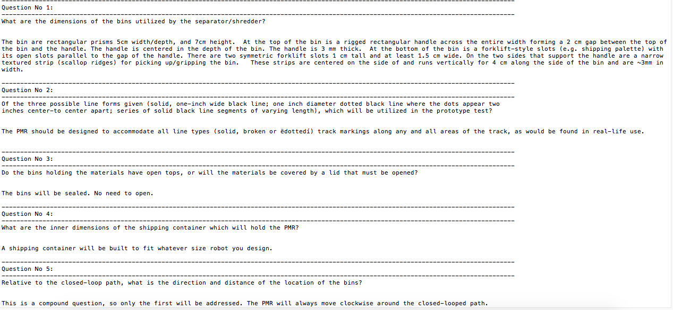

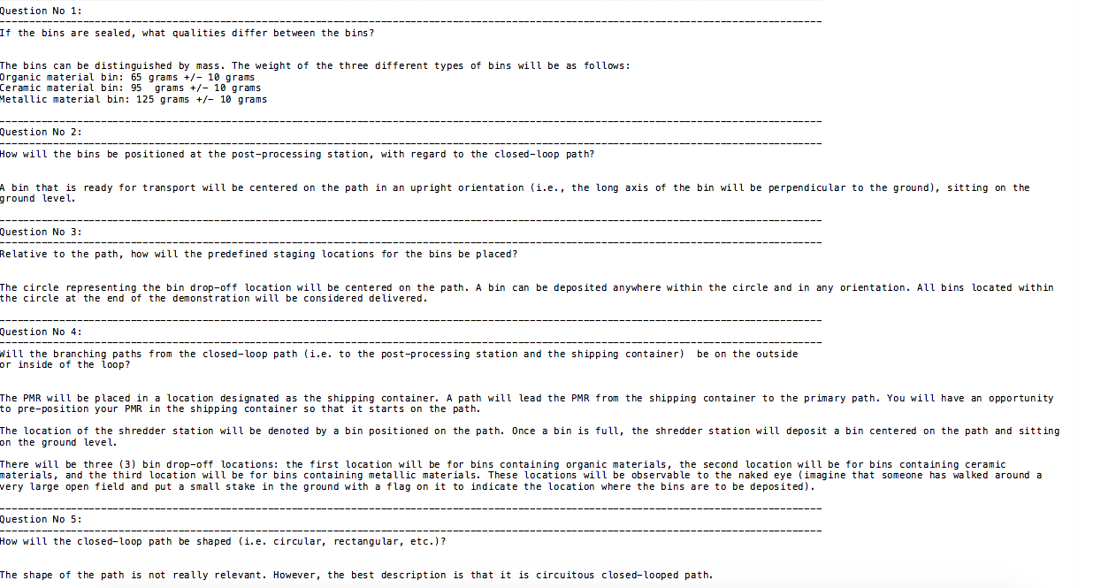

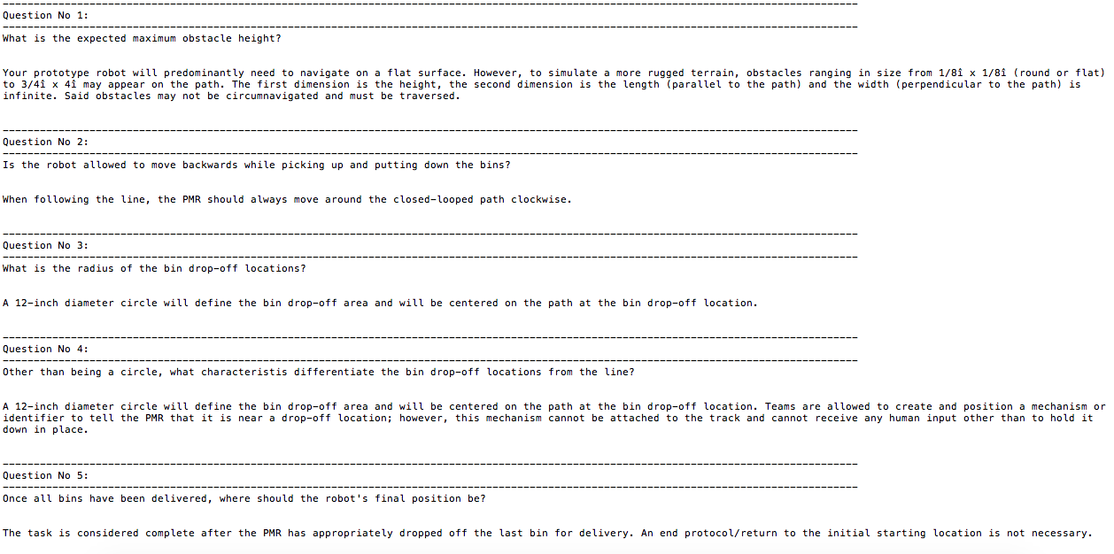

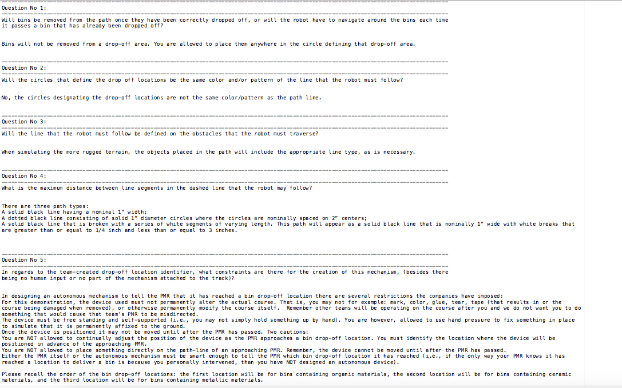

**Validations**--Updated November 18, 2015

Prototype 1:



The idea behind this mechanism was that the horizontal bars would move in a circular pattern while retaining their orientation in order to create a walking motion. At least 2 legs would be used on each side so that one set would be pushing the robot forward while the other would be reseting and moving forward. The legs would alternate pushing and resetting as the robot moved forward. Unfortunately, this design did not work because the horizontal bars did not retain their orientation, so the front of the bars rotated in a circular motion while the back of the bars were stationary. This would not have moved the robot. Another problem was that adding additional legs offset from the other ones would make the robot extremely wide. Additionally, the mechanism was fragile and used too many resources..



**Prototypes 2 & 3:**

Two eight-footed systems were created, with legs attached along the sides of the body, to have a greater range of motion. Moving every other foot simultaneously, so 2 legs on each side are always on the ground and push forward, while the other legs are resetting to push again.

These walking mechanisms were thought be more appropriate for the PMR, as it would give the PMR more stability and control. After testing, it was determined that the major problem with these designs was that it could not overcome taller obstacles. Many short legs limited the range of motion and do not allow the the PMR to climb over high obstacles



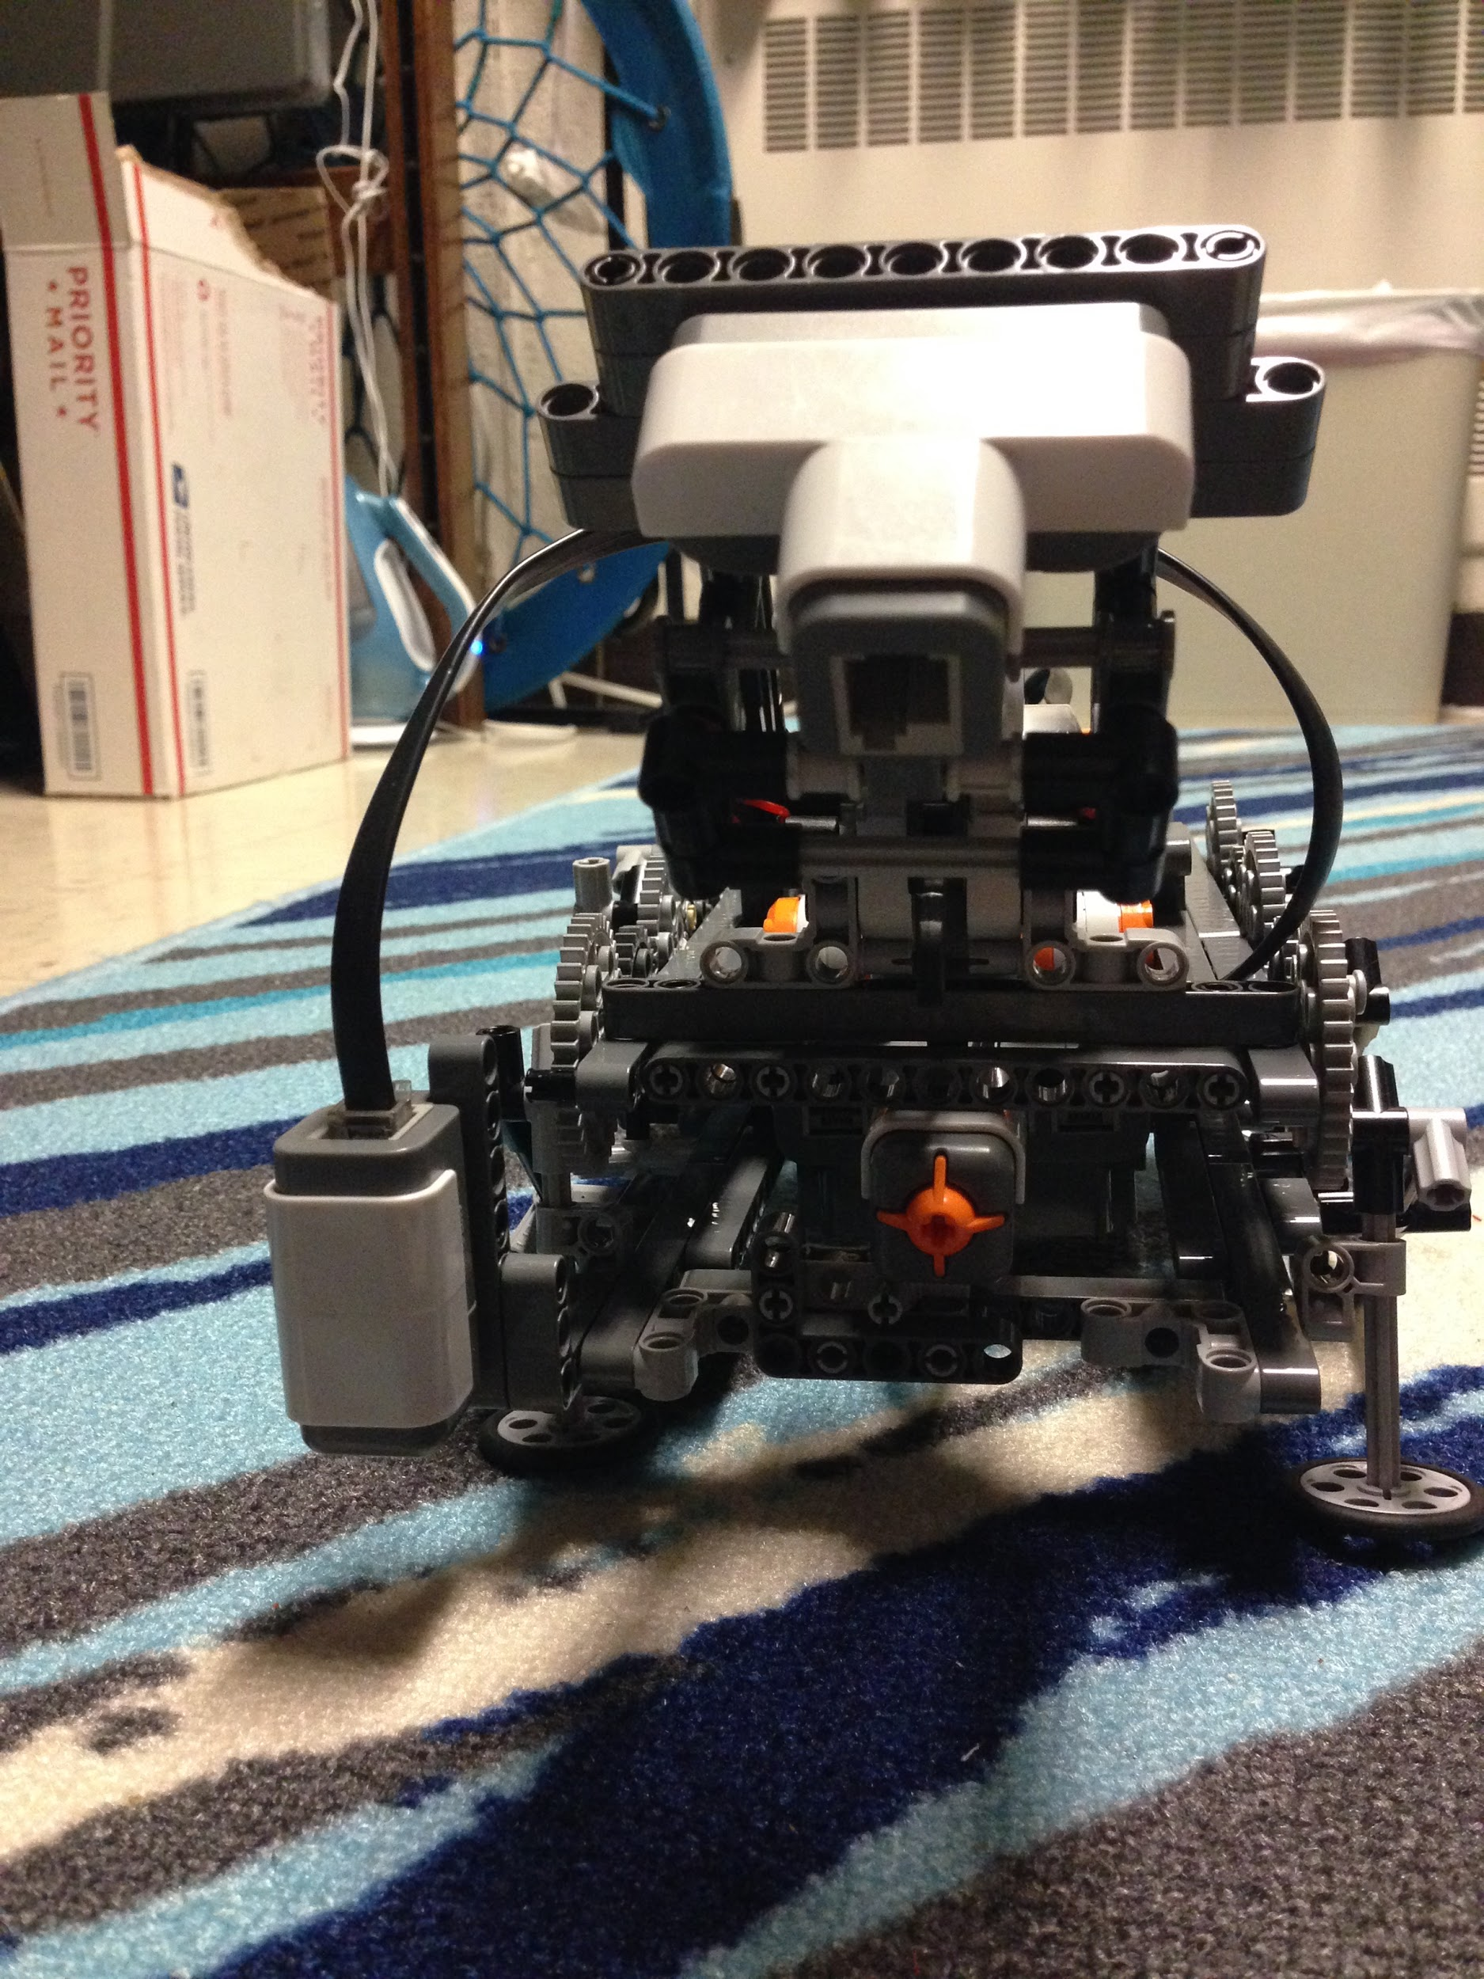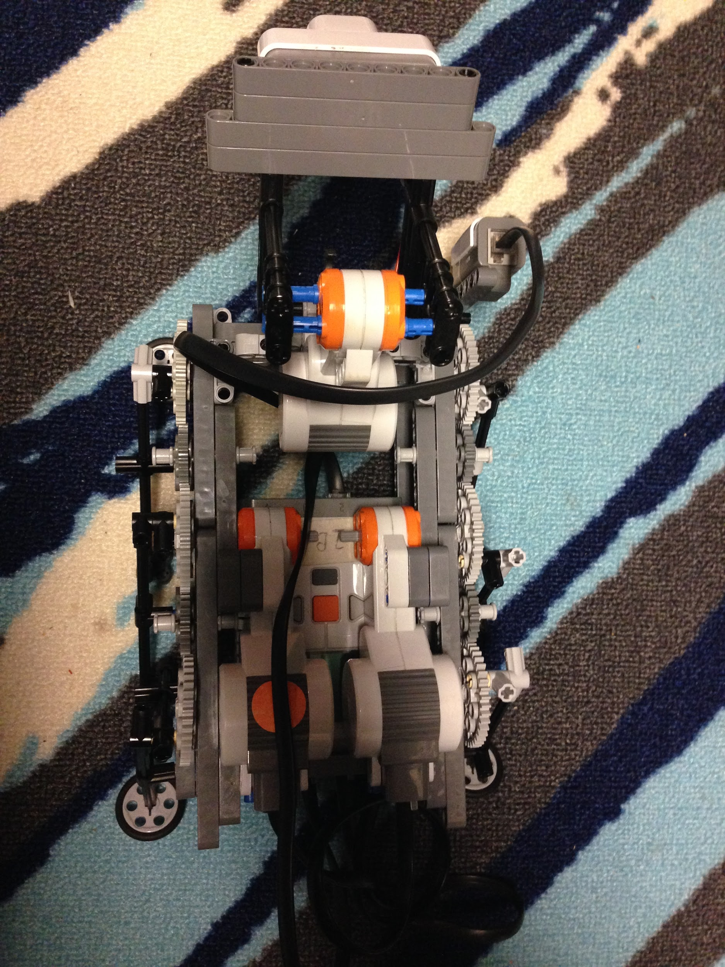

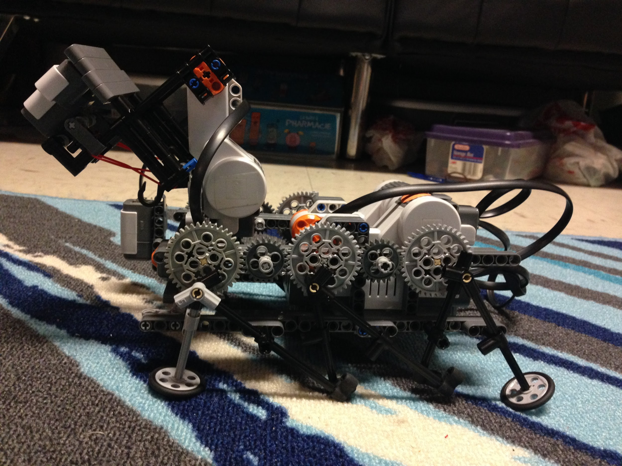

Grasping mechanism:

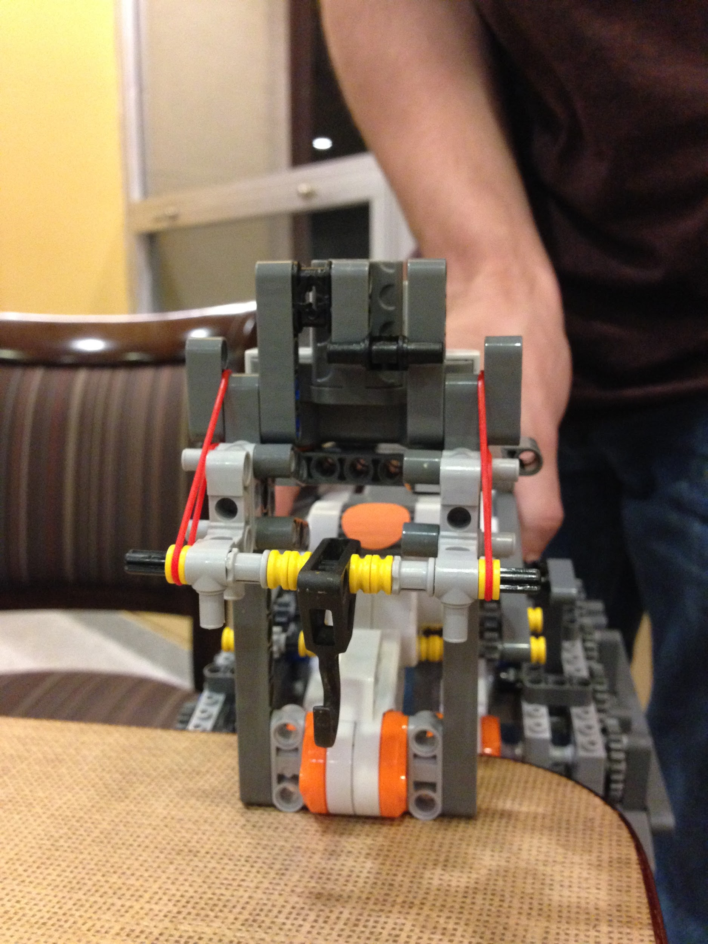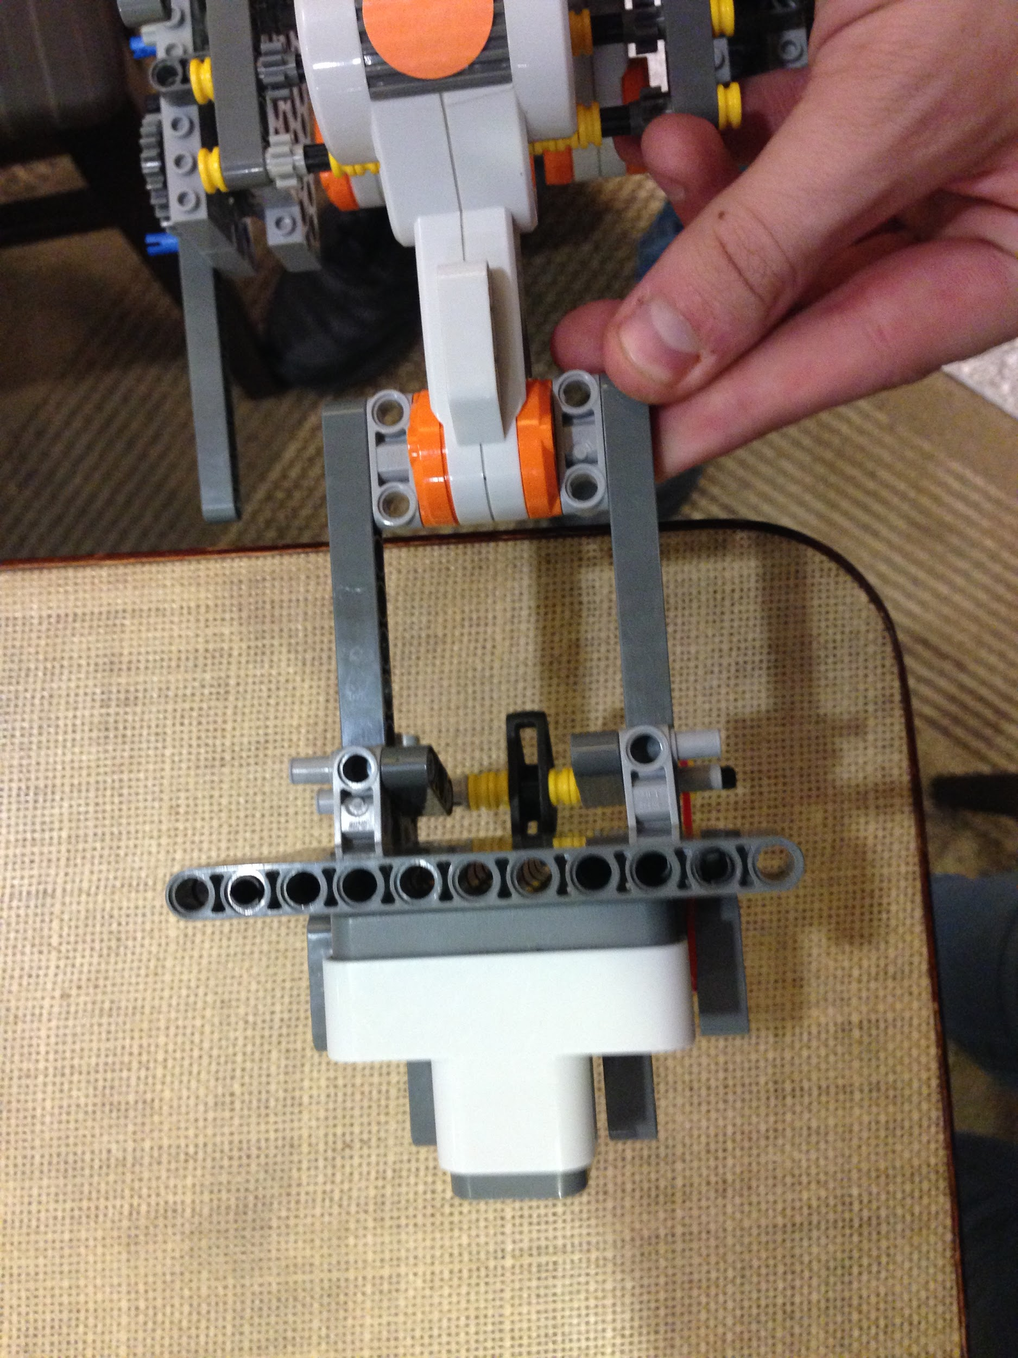

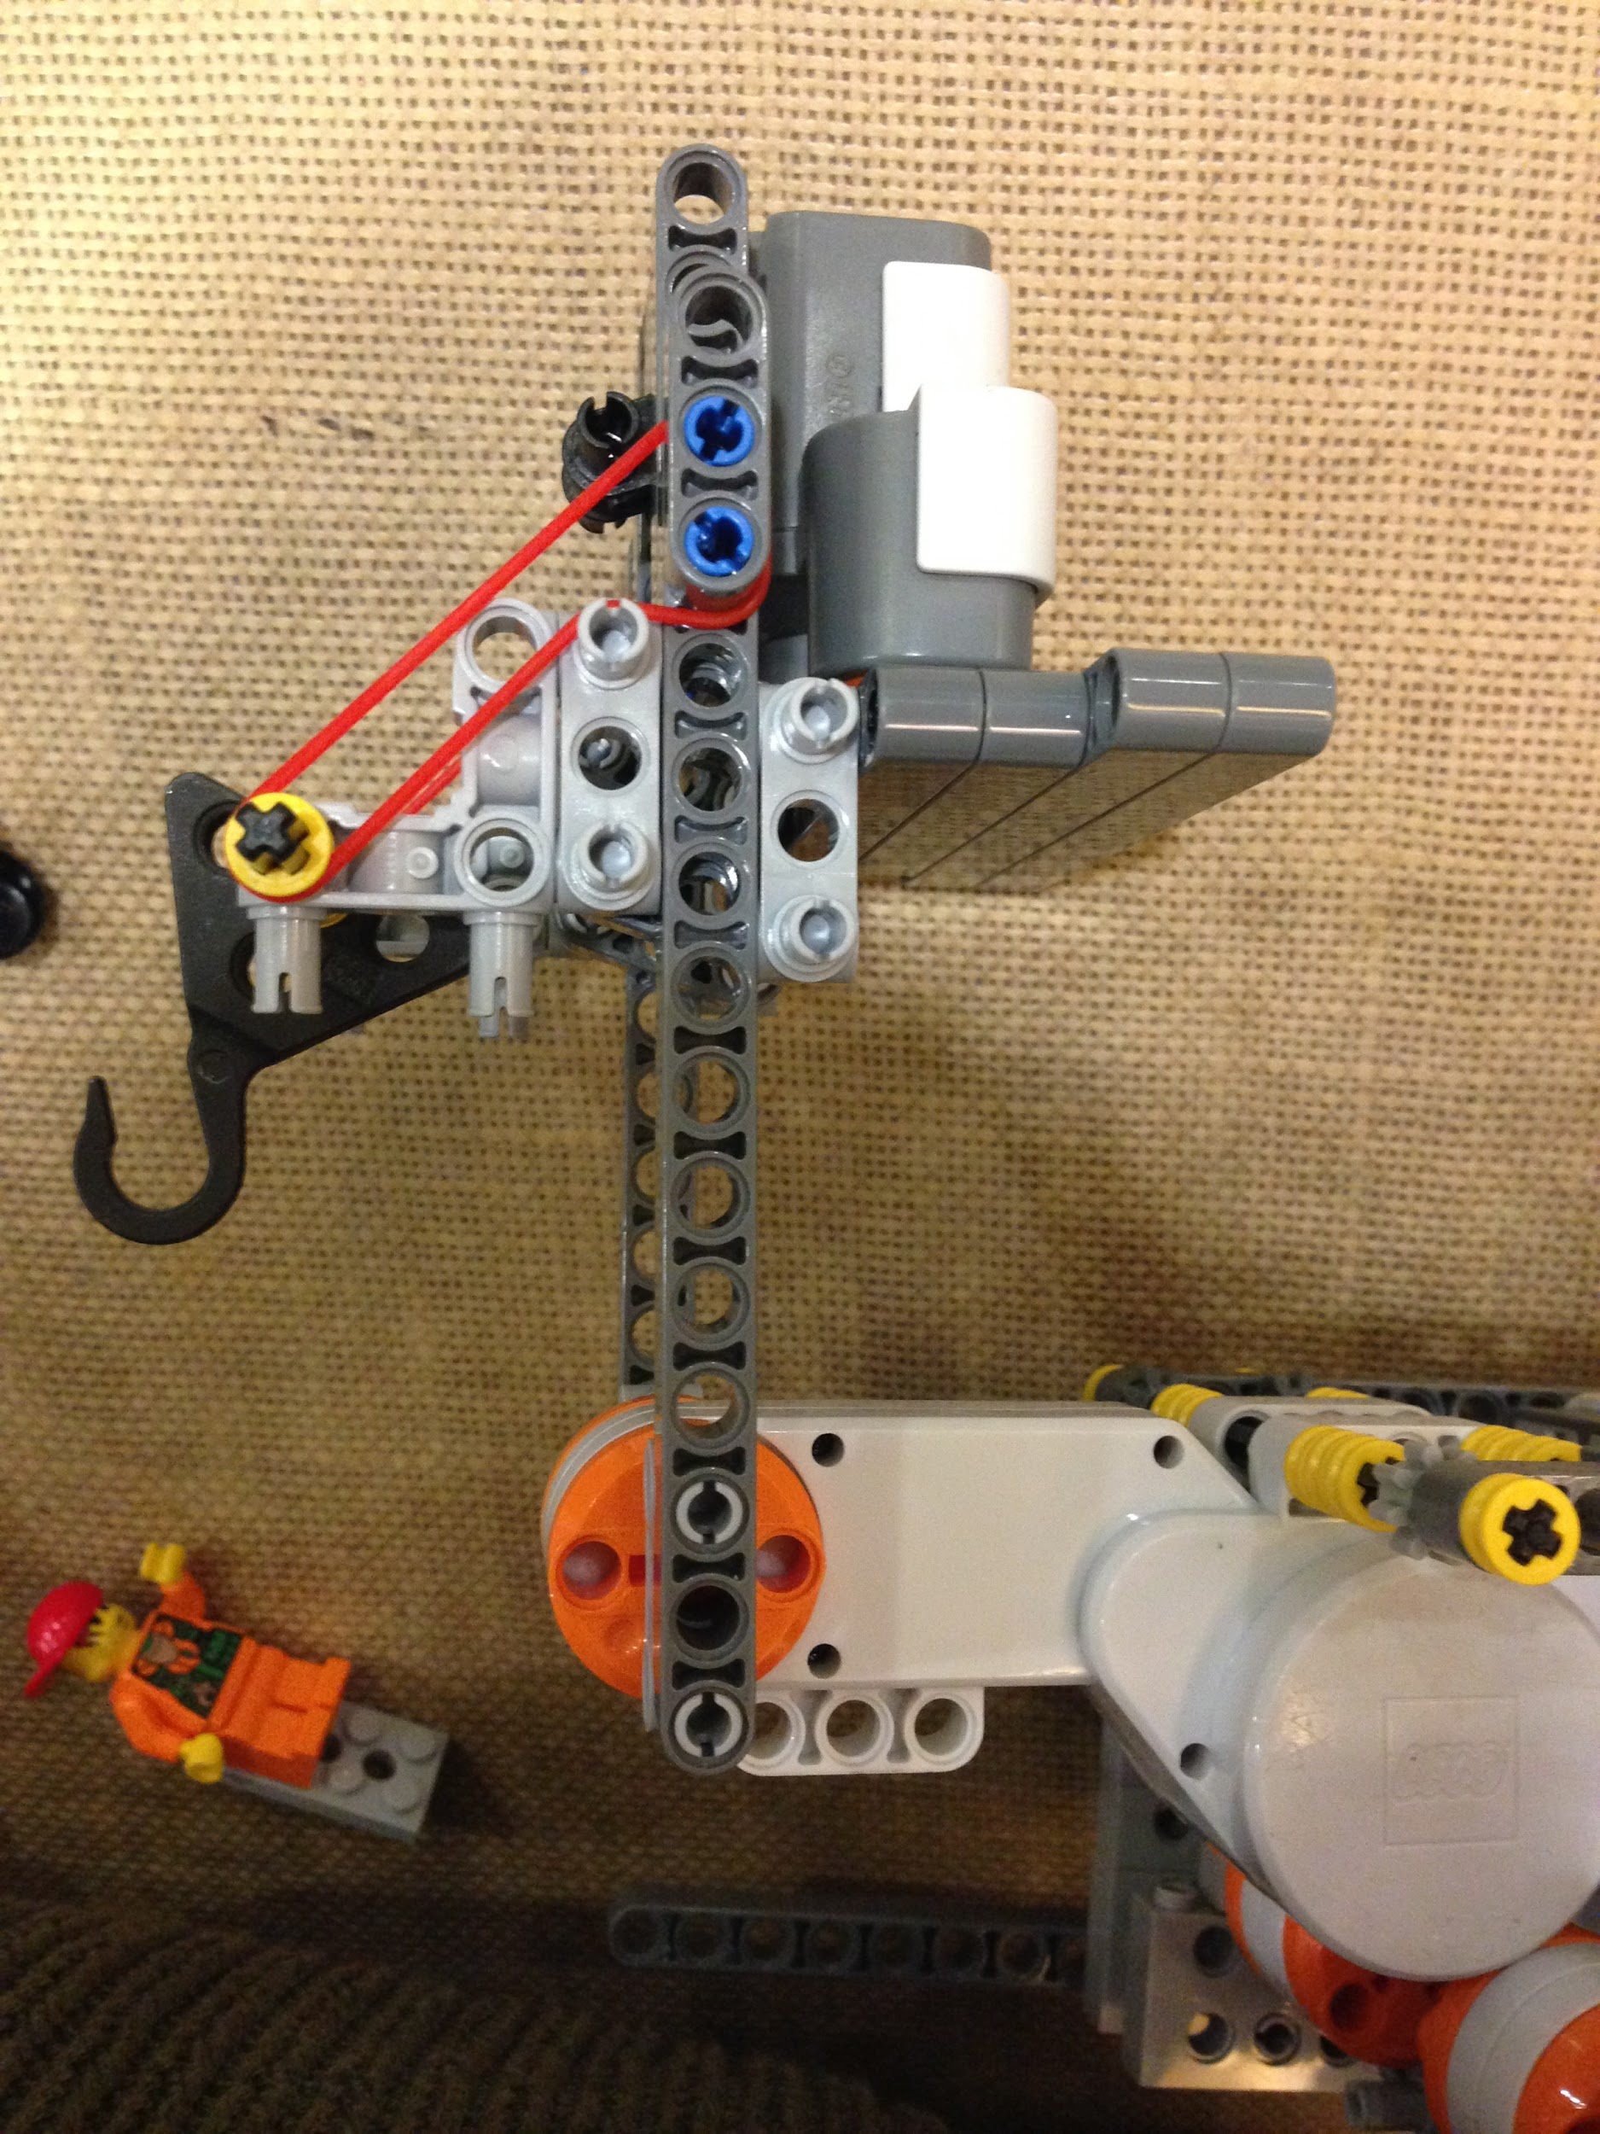

In order to pick up the bins, a combination hook/weighing mechanism was created. It consists of a motor, mounted at the top of the robot, with beams attached to the motor perpendicular to the axis of rotation. Between the beams, a sliding hook apparatus is installed such that the hook can slide towards and away from the motor. Rubber bands are wrapped around the hook apparatus to create resistance against movement of the hook towards the motor. Displacement of the sliding hook, and thus the mass of the bin, can be measured with an ultrasonic sensor. This mechanism would function as follows:

1. During movement, the beams and hook would be positioned vertically.
2. After arriving at the bin pick up location, the motor rotates forward 90º, placing the beams and hook parallel to the ground.
3. The PMR moves forward to capture the bin.
4. The motor rotates the beams and hook back to the vertical starting position.
5. Based on the displacement of the hook apparatus, an ultrasonic sensor determines bin mass.

**Prototype 4**

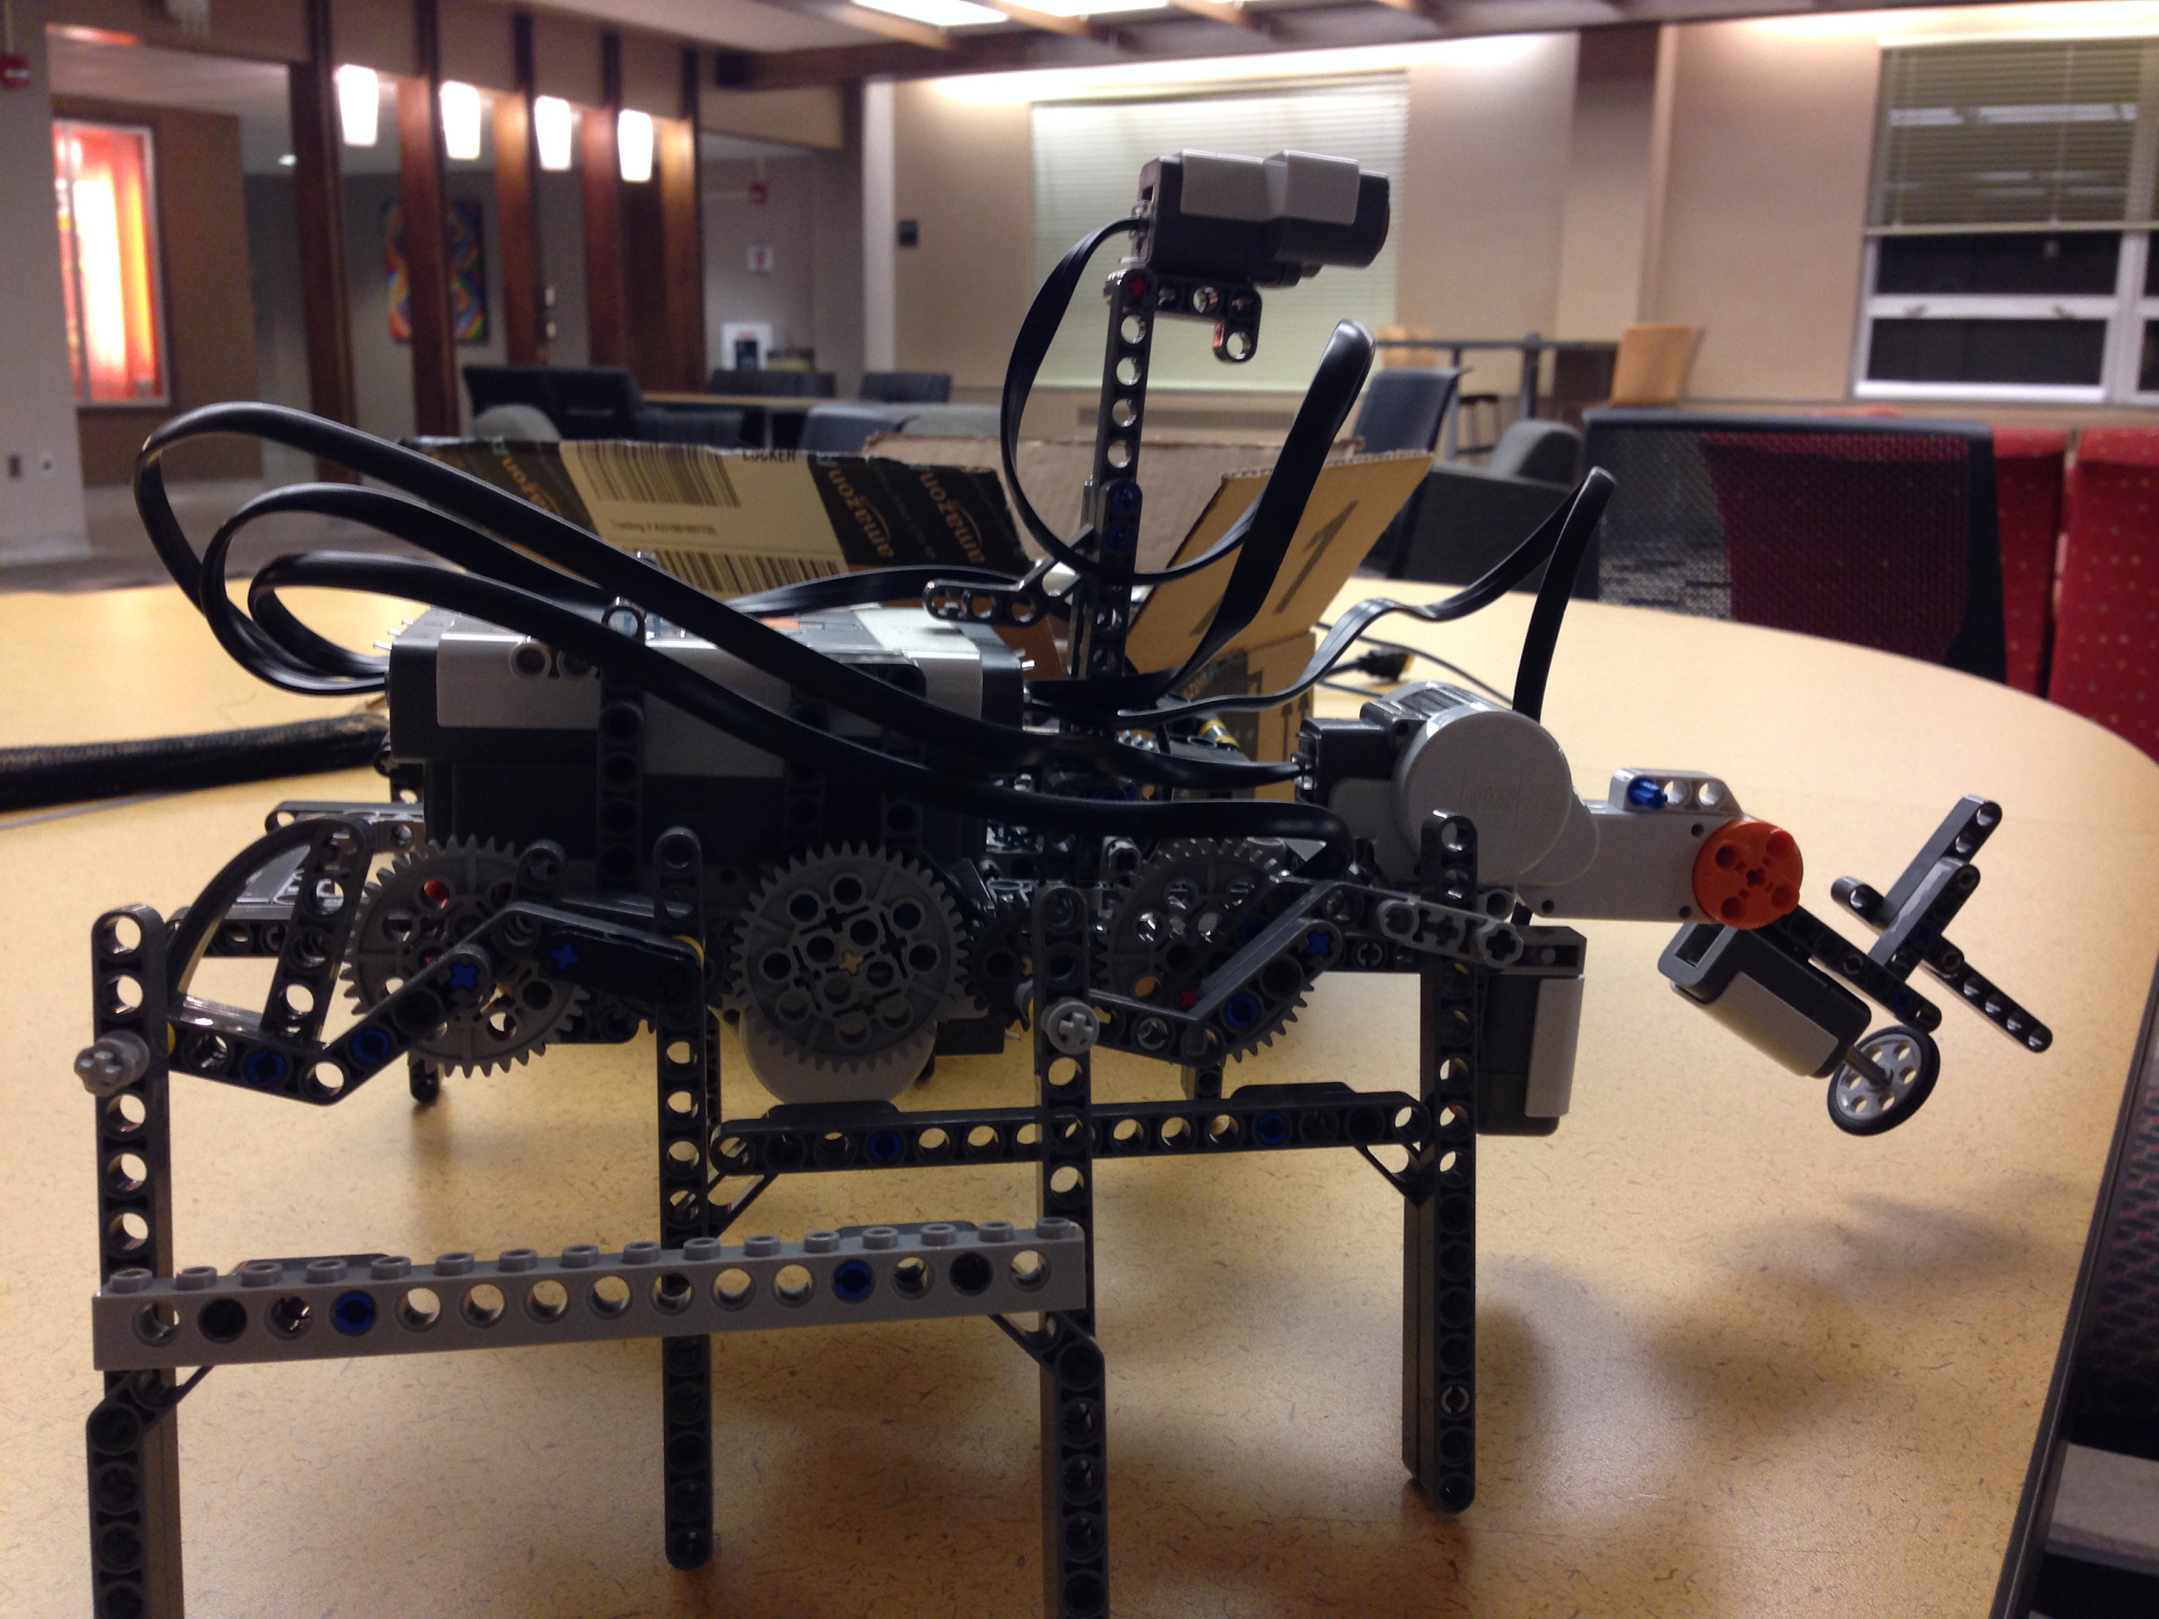

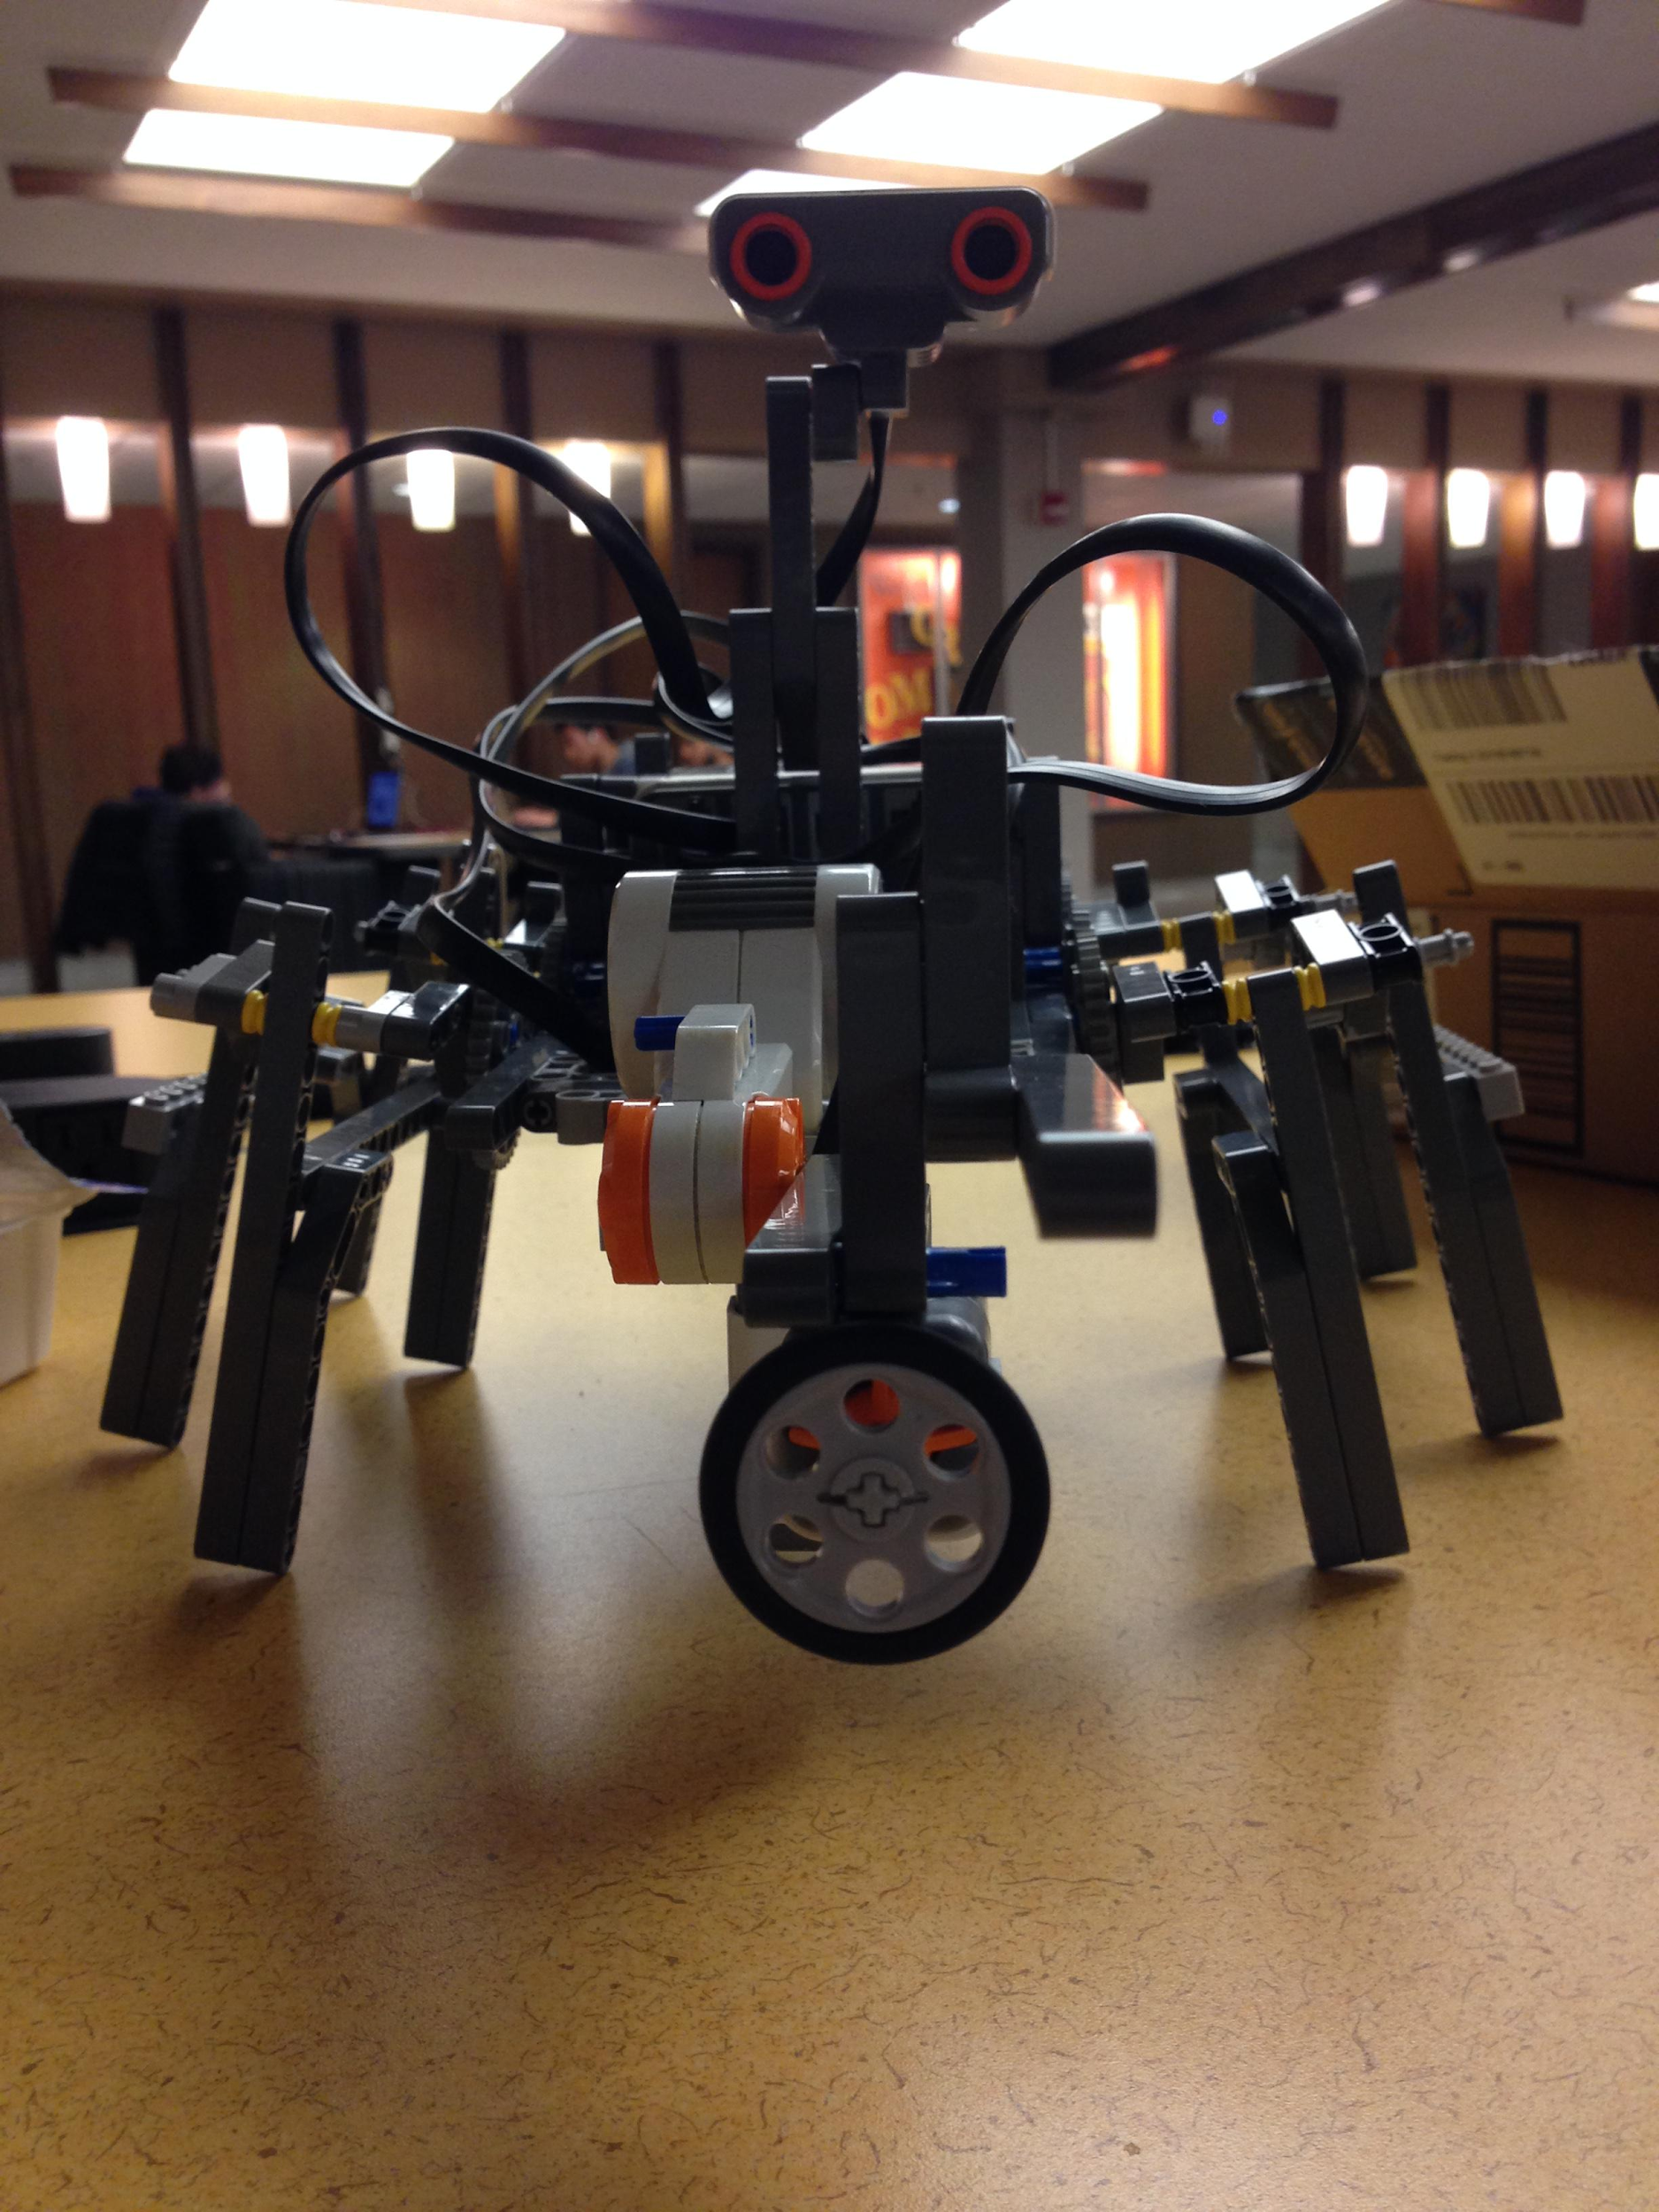

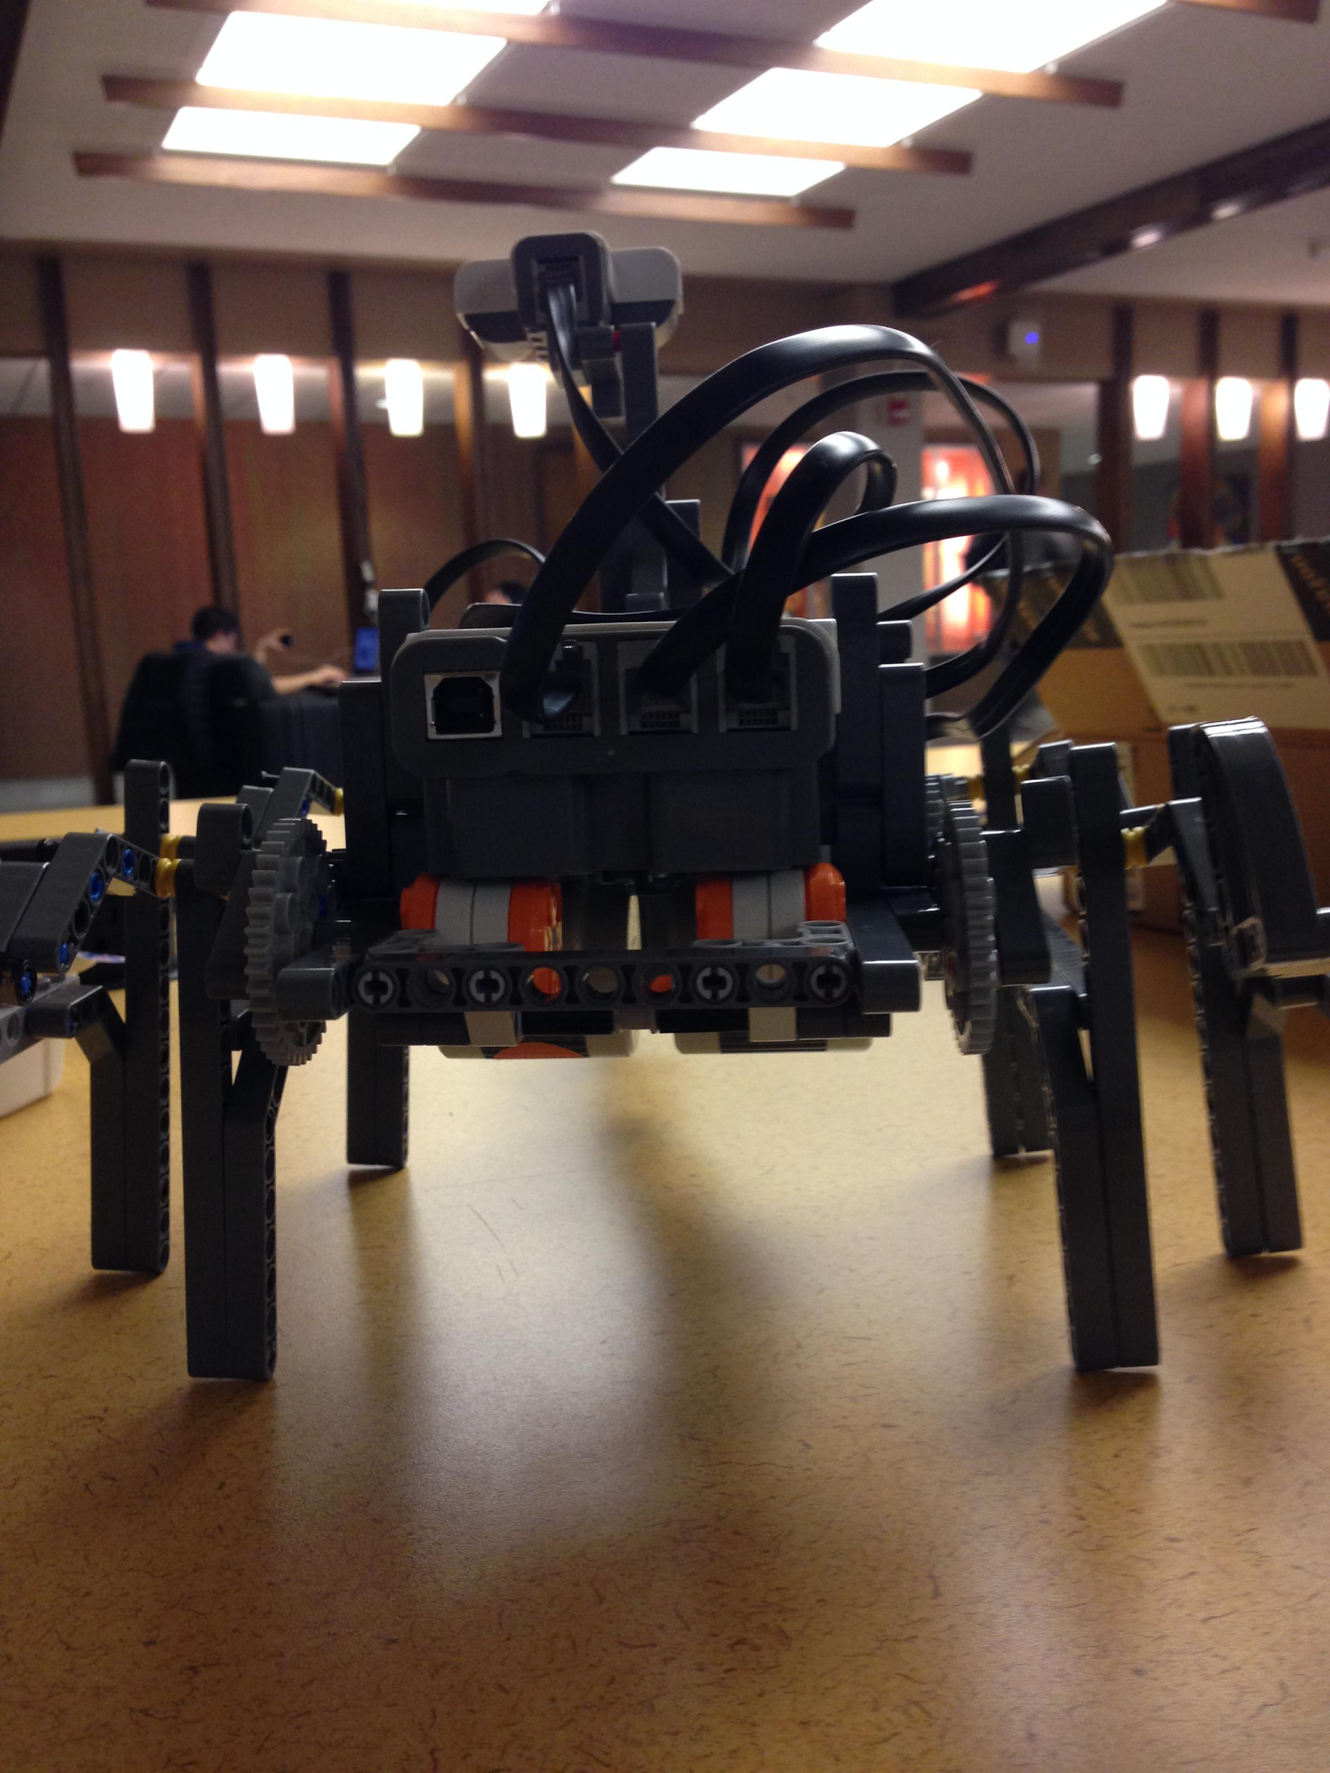

* Grasping & Bin-Identification mechanism

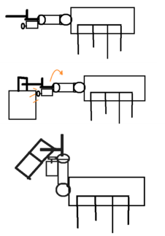

Once the touch was pressed the PMR stopped and moved the forklift back up with different powers to determine the bin content, and then outputted to the screen the content.

Different power levels are needed to lift different bins, and we can use this property to identify the content of the bins.

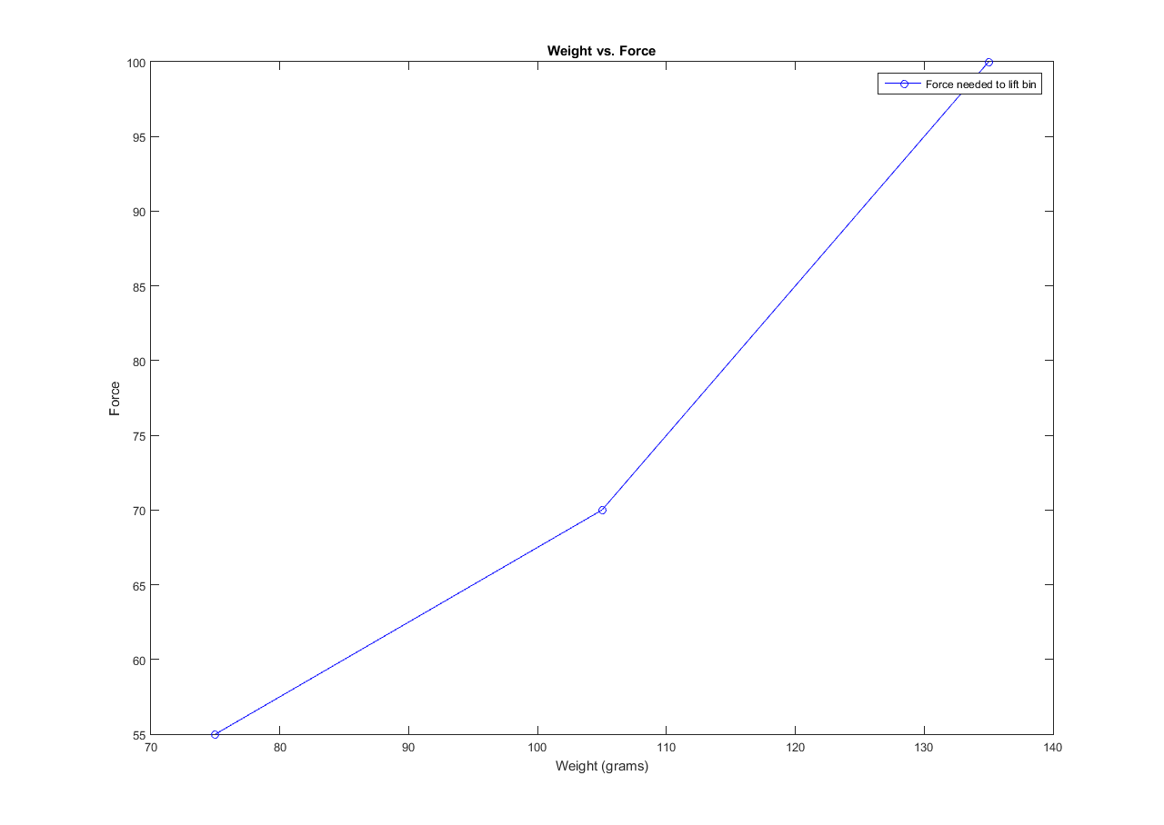

**Simulations** -- Updated December 7, 2015

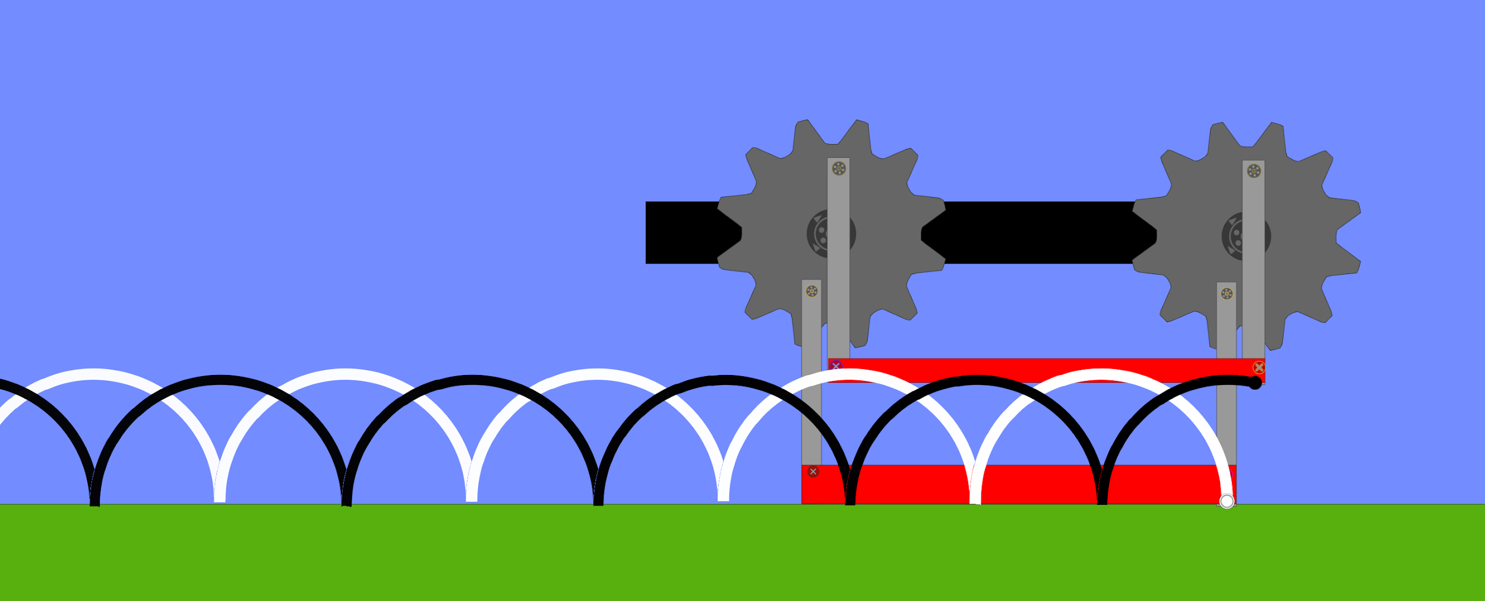

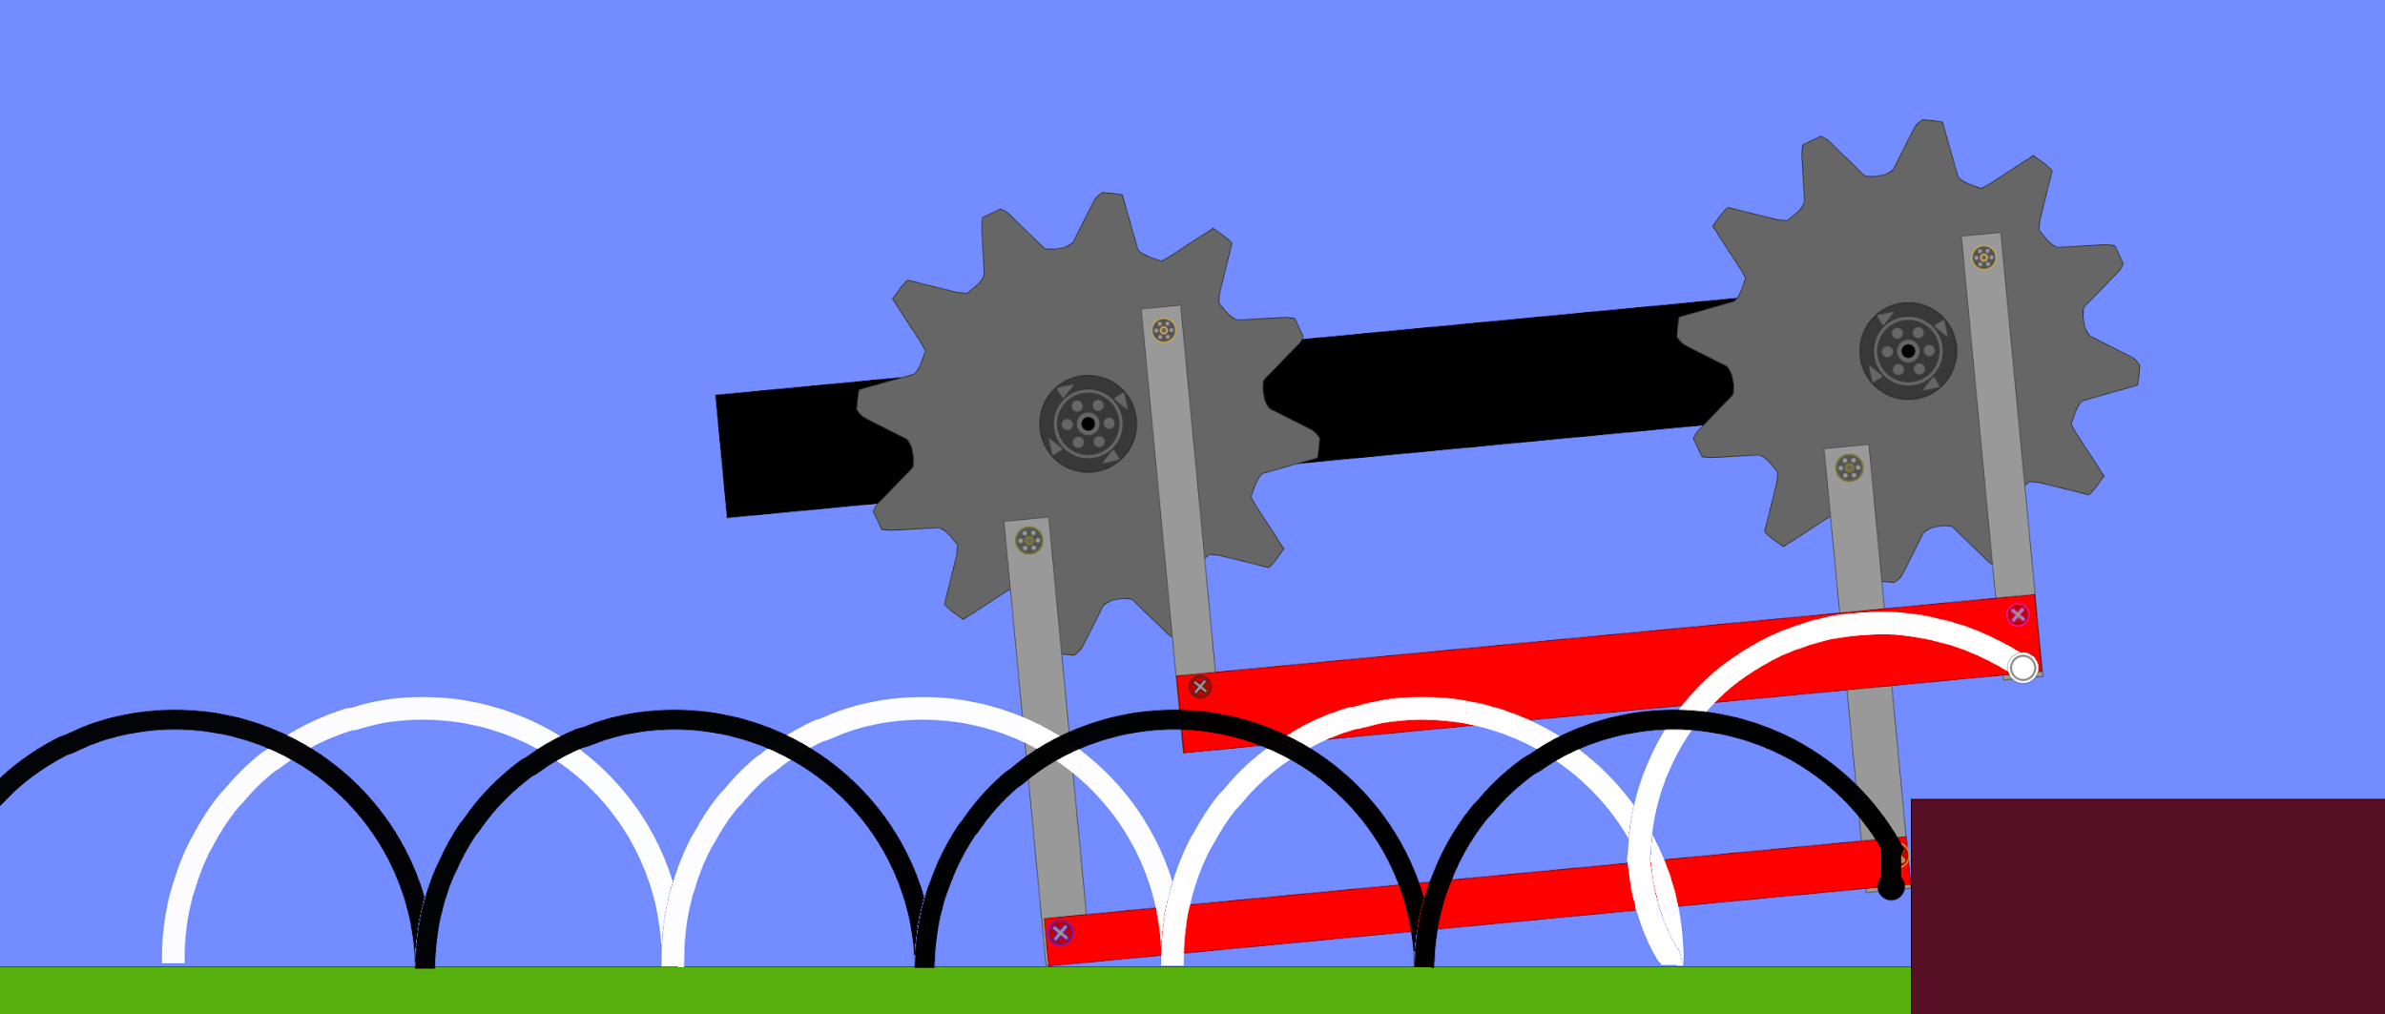

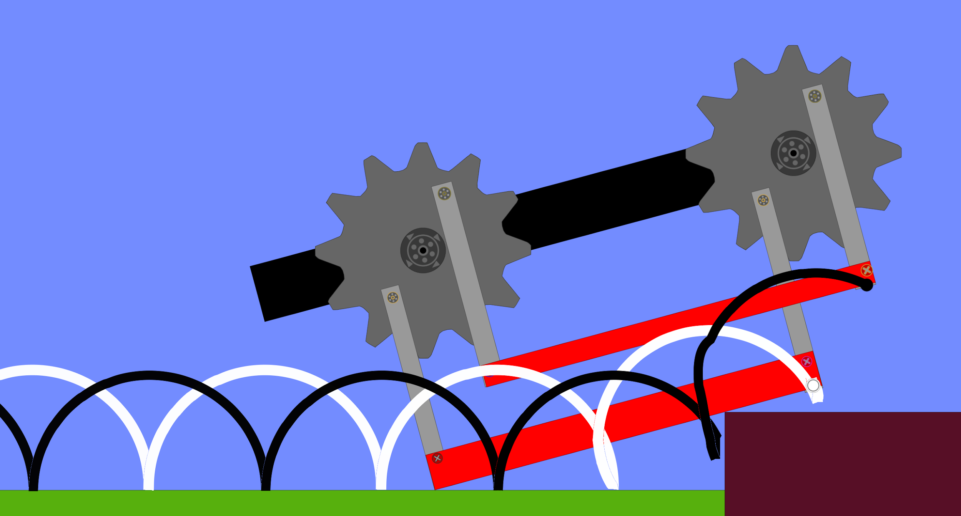

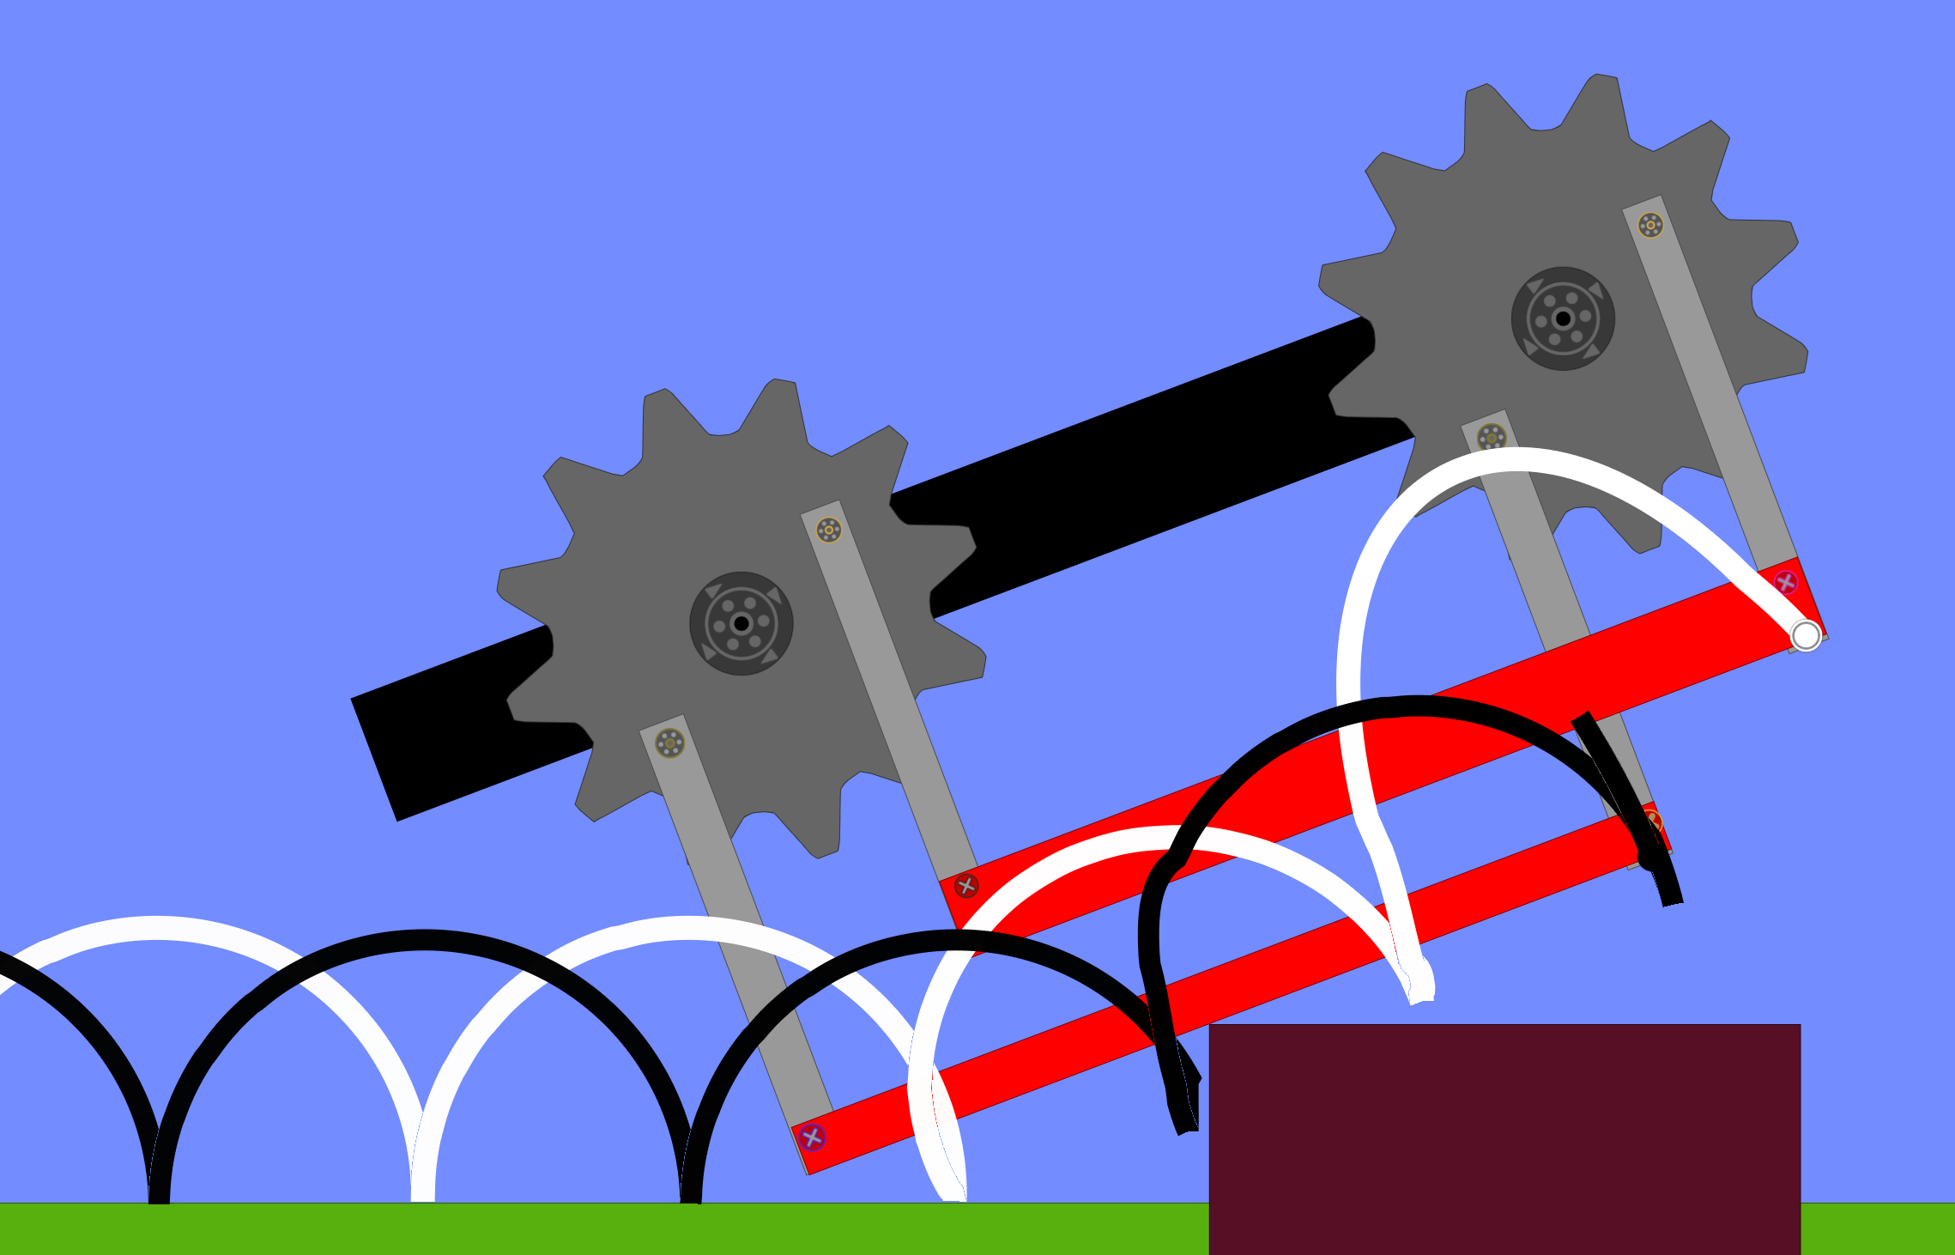

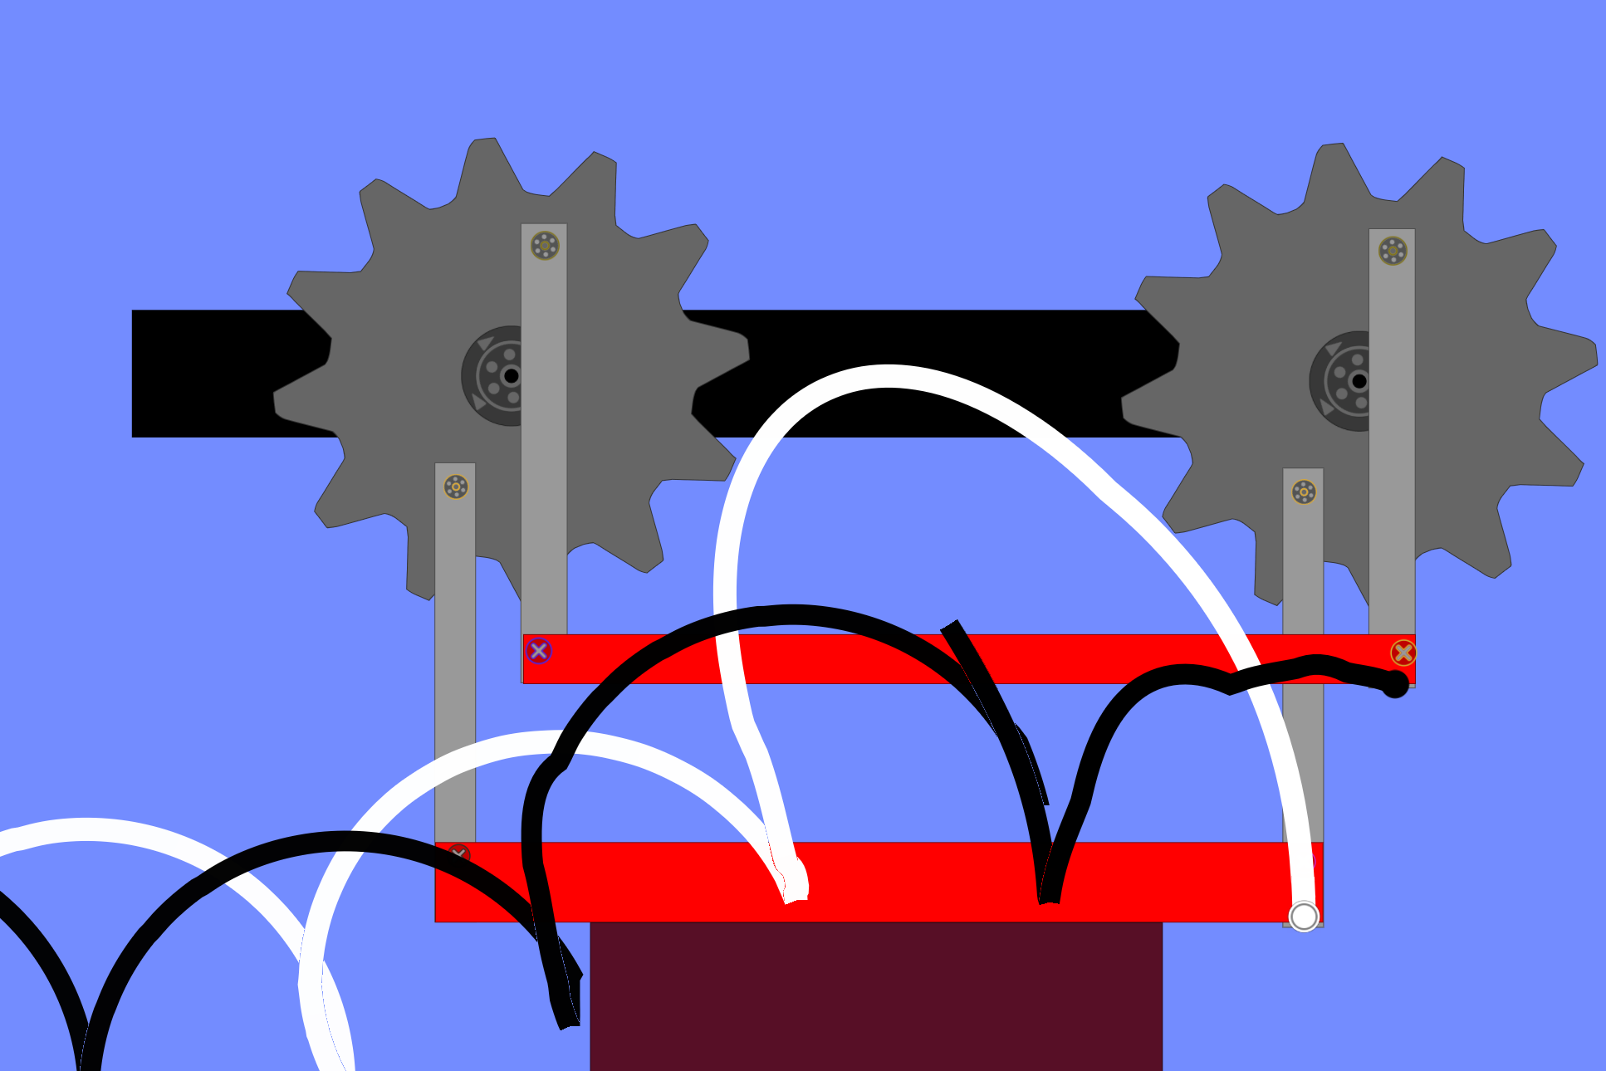

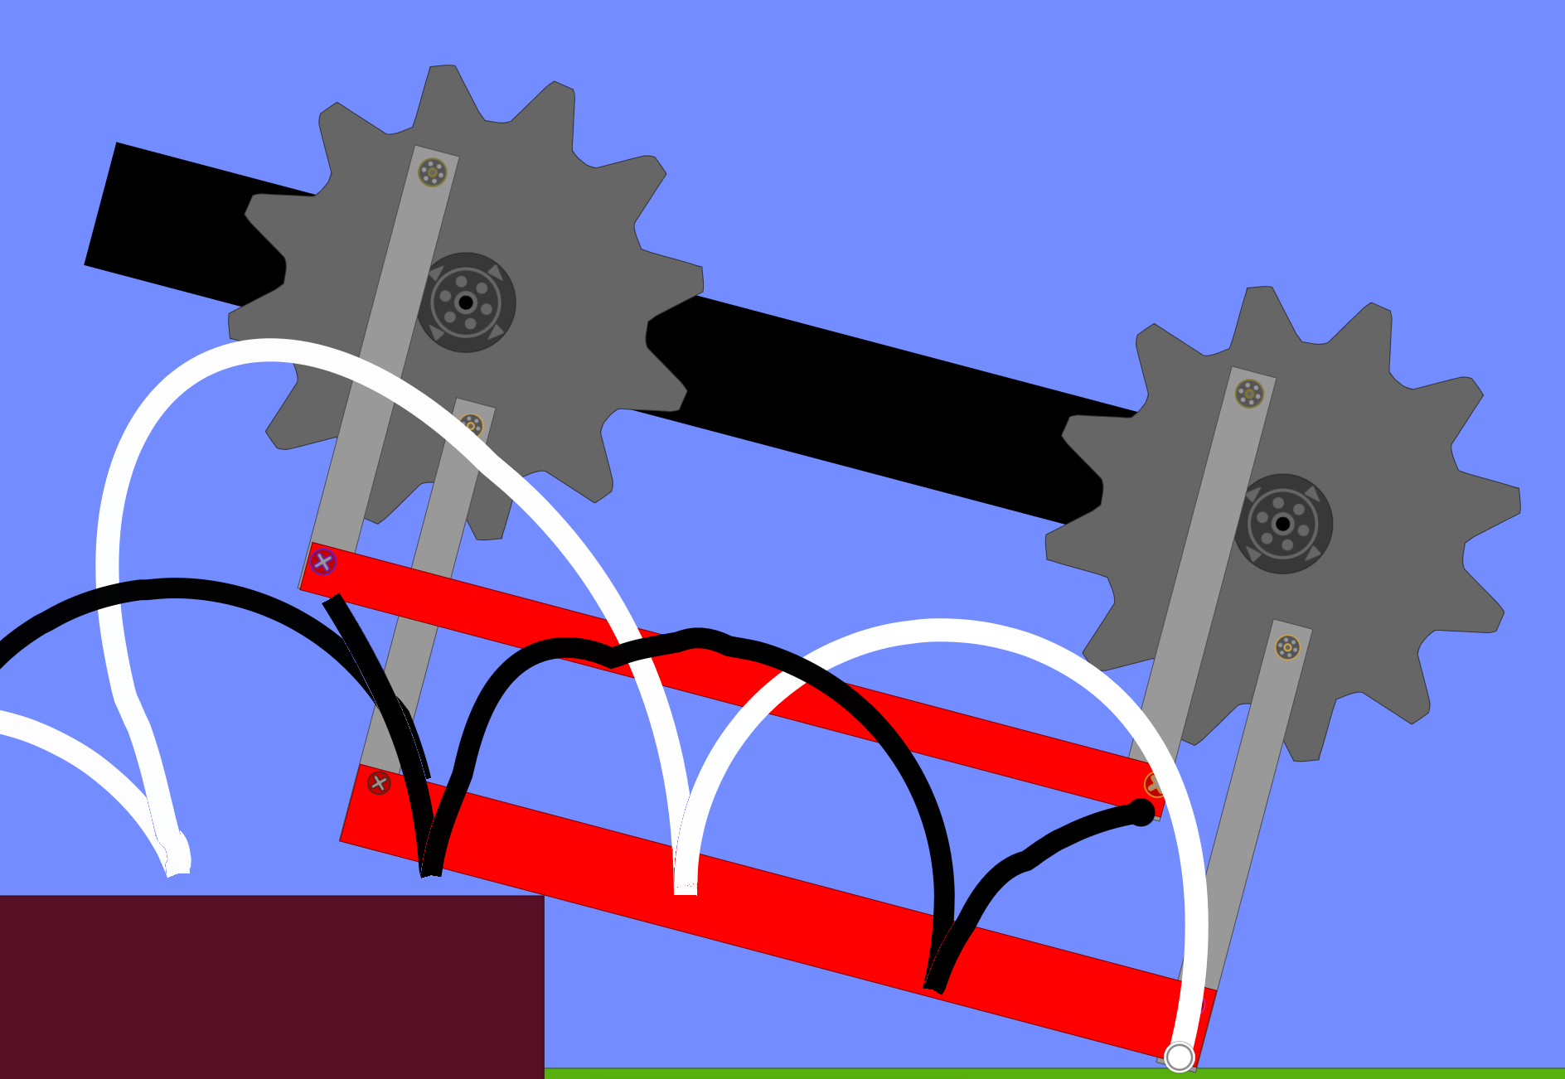

**Parts sketches:**

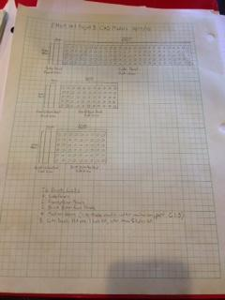

**Meeting Minutes**

Team Meeting 1: September 15, 2015

* parts counted by team members
* part totals entered into excel document
* team began work on robot prototype
* Electronic Signatures:
  + Kathryn Atherton
  + Ryan Hellyer
  + Natalie Zimmermann

Team Meeting 2: September 16, 2015

* part spot check done by team members
* re-count done by team
* new part totals entered into excel document
* Electronic Signatures:
  + Kathryn Atherton
  + Ryan Hellyer
  + Natalie Zimmermann

Team Meeting 3: September 20, 2015

* RFAI created and submitted by team with the following questions:

1.-What are the dimensions of the bins utilized by the separator/shredder?

2.- Of the three possible line forms given (solid, one-inch wide black line; one inch diameter dotted black line where the dots appear two inches center-to center apart; series of solid black line segments of varying length), which will be utilized in the prototype test?

3- Do the bins holding the materials have open tops, or will the materials be covered by a lid that must be opened?

4.- What are the inner dimensions of the shipping container which will hold the PMR?

5.- Relative to the closed-loop path, what is the direction and distance of the location of the bins?

* Electronic Signatures:
  + Kathryn Atherton
  + Ryan Hellyer
  + Natalie Zimmermann

Team Meeting 4: September 21, 2015

* Ryan Hellyer unavailable
* Rest of team attended recount
* Team obtained replenish of parts
* Electronic Signatures:
  + Kathryn Atherton
  + Natalie Zimmermann

Team Meeting 5: September 27, 2015

* Team finalized Gantt Chart
* Team began work on Resources Chart, PERT Chart
* Team organized project into tasks, designated R. Hellyer as robot project manager
* Team designated sub-components of Robot
* Team began to create metrics for sub-components
* Electronic Signatures:
  + Kathryn Atherton
  + Ryan Hellyer
  + Natalie Zimmermann

Team Meeting 6: September 28, 2015

* Team finished description of all the sub-components of the robot, with explanation of different functions and features
* Team made a metrics table, analyzing the sub-components, their needs, the technical needs and requirements and the target values to achieve.
* Initiated discussion on the workload distribution, pending to be completed in the next days
* Electronic Signatures:
  + Kathryn Atherton
  + Ryan Hellyer
  + Natalie Zimmermann

Team Meeting 7: September 29, 2015

* Experimented with the robot walker mechanism
* Completed workload distribution:
  + Ryan Hellyer as Robot Project Manager
  + Kathryn Atherton as Code Project Manager
  + Natalie Zimmermann as Design Notebook Project Manager
* Finished Design Specification Review
* Electronic Signatures:
  + Kathryn Atherton
  + Ryan Hellyer
  + Natalie Zimmermann

Team Meeting 8: October 1, 2015

* Team completed Request for Additional Information 2 with the following questions:

1.- If the bins are sealed, what qualities differ between the bins?

2.- How will the bins be positioned at the post-processing station, with regard to the closed-loop path?

3.- Relative to the path, how will the predefined staging locations for the bins be placed?

4.- Will the branching paths from the closed-loop path (i.e. to the post-processing station and the shipping container) be on the outside or inside of the loop?

5.- How will the closed-loop path be shaped (i.e. circular, rectangular, etc.)?

* Electronic Signatures:
  + Kathryn Atherton
  + Ryan Hellyer
  + Natalie Zimmermann

Team Meeting 9: October 2, 2015

* Ryan Hellyer unable to attend (excused absence)
* Team reverse-engineered animals--a spider and an elephant--to evaluate how they achieve mobility. Team then used this evaluation to identify critical factors associated with mobility.
* Team used brainstorming methods--more reverse-engineering of nature (penguins and inch worms)-- to develop a range of ideas for the mobility of the PMR.
* Team created a morph chart for the mobility of the PMR.
* Electronic Signatures:
  + Kathryn Atherton
  + Natalie Zimmermann

Team Meeting 10: October 6, 2015

* Team worked on the Presentation of Competencies
* Worked on “Engineering Specifications” for the PMR
* Reviewed robot’s walker mechanism
  + Previous design did not work
  + Reinforced problematic parts
* Electronic Signatures:
  + Ryan Hellyer
  + Natalie Zimmermann
  + Kathryn Atherton

Team Meeting 11: October 7, 2015

* Team worked on the walker mechanism
* Team measured the current performance of the PMR:
  + Speed: 0.238 feet per second
  + Move Straight: 45º deviation
  + Move Far : 38 inches without deviating
* Electronic Signatures:
  + Ryan Hellyer
  + Natalie Zimmermann
  + Kathryn Atherton

Team Meeting 11: October 17, 2015

* Reviewed PoC1 and corrected mistakes and clarified existing specifications
* Analyzed the robot’s walker mechanism with slow-motion recording to see where exactly it was failing
* Created a sketch for the parts team would like to print at the AFL
* Electronic Signatures:
  + Ryan Hellyer
  + Natalie Zimmermann
  + Kathryn Atherton

Team Meeting 12: October 18, 2015

* Team attended first PoC
* Worked on robot grasping mechanism:
  + Pick up boxes with hook
  + Will make use of ultrasonic sensor to measure how much the hook is pulled down by the weight of boxes
* Kathryn Atherton absent due to sickness

PoC 1 Performance:

|  |  |
| --- | --- |
| Task1 | PASSED |
| Task 2 | Not qualified (incomplete specifications) |
| Task 3 | FAILED: stuck at 3rd obstacle |
| Task 4 | No pick-up mechanism |
| Task 5 | Not qualified (incomplete specifications) |
| Task 6 | No pick-up mechanism |

* Electronic signatures:
  + Ryan Hellyer
  + Natalie Zimmermann

Team Meeting 13, October 26, 2015

* Team met in order to re-evaluate walker mechanism
  + Improve the range of motion
  + “Climb” higher obstacles
* Worked on grasping mechanism
  + Simpler
  + Use less materials
* Team used NX Siemens to model Lego Parts to print missing parts
* Electronic Signatures:
  + Ryan Hellyer
  + Natalie Zimmermann
  + Kathryn Atherton

Team Meeting 14, November 7, 2015

* Team revised Specifications document for PoC 2
  + Clarified some of the specifications on bin drop-off and disengagement
  + Added missing items
* Electronic Signatures:
  + Natalie Zimmermann
  + Ryan Hellyer
  + Kathryn Atherton

Team Meeting 15, November 10th 2015

* Team completely reconstructed the walker mechanism
* Fewer and longer legs
* Electronic Signatures:
  + Natalie Zimmermann
  + Kathryn Atherton

Team Meeting 16, November 14th 2015

* Continued working on the Walker Mechanism
  + 3 legs on each side
  + Connected with gears
  + Attached to the brick
* Updated the Metrics and the Functional Block DIagram
* Electronic Signatures:
  + Natalie Zimmermann
  + Kathryn Atherton
  + Ryan Hellyer

Team meeting 17, November 16th 2015

IN CLASS:

* Reviewed POC Specifications for POC 2
* Adjusted walking mechanism to the brick
* Worked on line following code
* Finished RFAI 4 questions
* Finished bins for the POC
* Flow chart for final integrated code created

EVENING:

* Completed House of Quality for robot
* Finished walking mechanism
* Electronic signatures:
  + Natalie Zimmermann
  + Kathryn Atherton
  + Ryan Hellyer

Team Meeting 18, November 18th, 2015

* Team met to prepare Presentation of Competency
* Attached sensors to robot:
  + Light sensor to follow the line
  + Touch sensor to “recognize” a bin
* Attached the final grasping mechanism to the robot
* Worked on line-following code
* Prepared the grasping mechanism for the PoC
* Completed House of Quality
* Electronic Signatures:
  + Natalie Zimmermann
  + Ryan Hellyer
  + Kathryn Atherton

Team Meeting 19, November 19th, 2015

* Worked on the bin drop-off location recognition
  + Touch sensor was used
  + When touch sensor pressed, robot would stop moving
  + Once released again, continued walking
* Improved the grasping mechanism
  + Calculated how much exactly the motor had to rotate
  + When exactly the robot had to stop to pick up the bin properly

POC 2 Performance

|  |  |
| --- | --- |
| Task1 | PASSED |
| Task 2 | FAILED: Did not follow line |
| Task 3 | FAILED: Stuck at 3rd obstacle |
| Task 4 | PASSED |
| Task 5 | FAILED: Missed the bin |
| Task 6 | No bin ID mechanism |

* Electronic Signatures:
  + Natalie Zimmermann
  + Kathryn Atherton

Team Meeting 20, November 21, 2015

* Team met to work on the Project 3 Draft Report
  + Finished cover letter
  + Finished executive summary
  + Design section needs improvement
* Run simulation on various designs
* Tested the robot
  + Obstacles
  + Bin Id
  + Pick-Up mechanism
* Electronic Signatures
  + Natalie Zimmermann
  + Kathryn Atherton
  + Ryan Hellyer

Team Meeting 21, November 22, 2015

* Team finished writing the draft report
  + Conclusion and Recommendation section was finished
  + Results and Discussion section was finished
* Electronic Signatures
  + Natalie Zimmermann
  + Kathryn Atherton
  + Ryan Hellyer

Team Meeting 22, December 1, 2015

* Worked on physical robot
  + Attached the ultrasonic sensor to identify the bin drop-off locations
  + Attached the touch sensor to identify that a bin has to be picked up
* Worked on the code for the robot
  + Line following code
  + Created loop until a certain conditions are met
    - Touch sensor -- A bin has to be picked up
    - Ultrasonic sensor -- Bin drop-off location has been reached
  + Defined actions that have to be done when conditions met
    - Move motor up to pick up bin (touch sensor)
    - Move motor down to release bin (ultrasonic sensor)
* Goal for next meeting: How to identify bins
  + Idea : How much force is needed to pick the bins up
* Electronic signatures:
  + Natalie Zimmermann
  + Kathryn Atherton

Team Meeting 23, December 4 2015:

* Finished with walking mechanism
* Created new mechanism ob bin identification
  + Try to pick up bins with different powers
  + Touch sensors to see when the in has been lifted
  + Different weights → Different powers
  + Use switch cases
  + Organic power 55
  + Ceramic power 70
  + Metallic power 100
* Tested

Bin Identification:

|  |  |  |
| --- | --- | --- |
| Content | Correct | Tested |
| Organic | 5 | 5 |
| Ceramic | 3 | 5 |
| Metallic | 5 | 5 |

Drop- Off Locations: Sense an object closer than 12 inches

→ Tested 6 times, 5 correctly sensed

-- We believe that the ones that were wrong were due to low battery power, so motor works slower (more power needed), which can cause confusion with bin pick-up. Also, alternate sensors’ readings

* Electronic Signatures
  + Natalie Zimmermann
  + Kathryn Atherton
  + Ryan Hellyer

Team Meeting 24, December 6, 2015

* Performed testing with prototype

Obstacle Traversal Testing

|  |  |
| --- | --- |
| 0.75 inches | Yes |
| 1 inch | Yes |
| 1.75 inches | Yes |

* Worked on project presentation
* Completed decision matrix to compare and contrast the different designs and how they meet the requirements
  + Forklift pick-up mechanism to pick-up bins
  + Last design “spider and elephant” for walking mechanism
  + Ultrasonic sensor as bin drop-off locator
  + Power needed to lift the bin as bin identifier

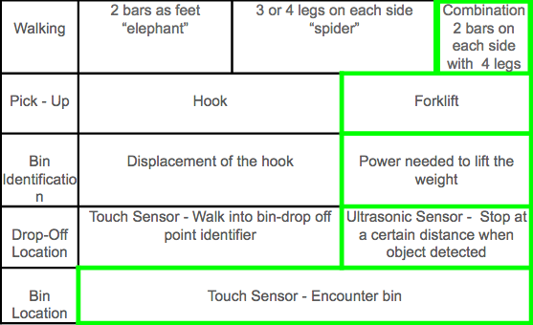

Team Meeting 26, December 6, 2015

* Team finished testing of all the specifications with the design chosen
* Finished final presentation
  + Only the conclusions/performance part left
* Finished up the code
* Electronic Signatures:
  + Natalie Zimmermann
  + Ryan Hellyer
  + Kathryn Atherton

PERFORMANCE

The robot started on the main track. After walking a few steps it deviated from the line, as it could not read the line properly. Also, the motors were not strong enough the legs did not move anymore

LINE FOLLOWING TESTING

|  |  |  |  |
| --- | --- | --- | --- |
| Checkpoint 1 | Checkpoint 2 | Checkpoint 3 | Checkpoint 4 |
| Yes | No | No | No |

MAINTRACK

The robot did not get far on the main track as it deviated soon and could not find a line.

Team Meeting 28, December 8, 2015

* Team met to finish the oral presentation
  + Added the factual performance
* Team practiced the oral presentation
* Electronic Signatures:
  + Natalie Zimmermann
  + Kathryn Atherton
  + Ryan Hellyer

Team Meetings 29 & 30, December 9-11m, 2015

* Finished working on the final report
* Electronic Signatures
  + Natalie Zimmermann
  + Kathryn Atherton
  + Ryan Hellyer